**TRIBHUVAN UNIVERSITY**

**INSTITUTE OF ENGINEERING**

ADVANCED COLLEGE OF ENGINEERING AND MANAGEMENT

DEPARTMENT OF ELECTRONICS AND COMPUTER ENGINEERING

BALKHU, KATHMANDU



**A Major Project Report On**

**3D DRONE MAPPING**

**PROJECT CODE: EX755**

**Submitted By:**

Aman Ansari (24901)

Amit Safi (24902)

Binay Kumar Sah (24904)

Karan Sunar (24911)

A project report submitted to the department of Electronics and Computer Engineering in the partial fulfillment of the requirements for degree of Bachelor in Electronics and Communication Engineering

Kathmandu, Nepal

**Supervised By:**

Er. Laxmi KC

12 April 2022

**ADVANCED COLLEGE OF ENGINEERING AND MANAGEMENT**

**DEPARTMENT OF ELECTRONICS AND COMPUTER ENGINEERING**

# LETTER OF APPROVAL

The undersigned certify that they have read and recommended to the Institute of Engineering for acceptance, a project report entitled “3D DRONE MAPPING” submitted by:

Aman Ansari 24901

Amit Safi 24902

Binay Kumar Sah 24904

Karan Sunar 24911

In partial fulfillment for the degree of Bachelor in Electronics and Computer Engineering.

…………………………

Supervisor

Er. Laxmi KC

Master in Electronic and Communication Engineering

…………………………

External Examiner

………………………

Er. Ajaya Shrestha

Head of Department

Senior Lecture

Department of Computer and Electronics

Date:

# COPYRIGHT

The author has agreed that the library, Advanced College of Engineering and Management, may make this report freely available for inspection. Moreover, the author has agreed that permission for extensive copying of this report for scholarly purposes may be granted by the supervisor, who supervised the project work recorded herein or, in their absence, by the Head of the Department wherein this project was done. It is understood that due recognition will be given to the author of this report and to the Department of Computer and Electronics Engineering, Advanced College of Engineering and Management in any use of the material of this report. Copying or publication or other use of this report for financial gain without approval of the Department of Computer and Electronics Engineering, Advanced College of Engineering and Management and authors' written permission is prohibited.

Request for permission to copy or to make any other use of the material in this report in whole or in part should be addressed to:

Head

Department of Computer and Electronics Engineering,

Advanced College of Engineering and Management

Balkhu, Kathmandu,

Nepal

# ACKNOWLEDGMENT

We would like to express our sincere gratitude towards the Institute of Engineering, Tribhuvan University for the inclusion of a Major Project in the course of Bachelors of Electronics and Communication Engineering. We are thankful to our Supervisor Er. Laxmi KC, Department Head Er. Ajay Shrestha and the Department of Electronics and Computer Engineering, Advanced College of Engineering and Management for their insightful advice and invaluable suggestions that were needed for this project.

We would also like to thank the Research and Innovation Unit (RIU) of Advanced College of Engineering and Management for their valuable advice, motivation, guidance, for providing us the needed components along with the suitable workspace to test our system.

The in-time facilities provided by the department throughout the Bachelors program are also equally knowledgeable.

We would like to convey our thanks to the teaching and non-teaching staff of the Department of Electronics & Communication and Computer Engineering, ACEM for their invaluable help and support throughout the period of Bachelor’s Degree. We are also grateful to all our classmates for their help, encouragement and invaluable suggestions.

Finally, yet more importantly, we would like to express our deep appreciation to our parents, sister and brother for their perpetual support and encouragement throughout the Bachelor’s degree period.

Aman Ansari (24901)

Amit Safi (24902)

Binay Kumar Sah (24904)

Karan Sunar (24911)

# ABSTRACT

This paper presents an application of Unmanned Aerial Vehicle (UAV) that is designed to take a number of overlapped aerial images of a subject area. These overlapped 2D images are later used to generate their 3D map using a Photogrammetry Software. The system uses a quadcopter drone equipped with an auto-controlled flight controller and a digital camera for the high-definition pictures of an open field that is supposed to be mapped.

However, Mapping techniques through remote sensing, 3D earth modeling using GIS and GPS techniques have now achieved significant progress these days, it’s still expensive for data acquisition and becomes a major concern if the area is small and requires a frequent number of updates. One alternative to solve this problem is to use an Unmanned Aerial Vehicle (UAV) which is cheaper and provides a wider range of flexibility for repetitive use. Outcome shows drone needs to be highly stable for the unshaken aerial photographs. Also, the higher number of overlapped images increases the quality of 3D map. Picture from different angle of views is essential for high quality noise free 3D map.

# TABLE OF CONTENTS

LETTER OF APPROVAL i

COPYRIGHT ii

ACKNOWLEDGMENT iii

ABSTRACT iv

TABLE OF CONTENTS v

LIST OF FIGURES viii

LIST OF TABLES x

CHAPTER 1: INTRODUCTION 1

1.1 BACKGROUND 1

1.2 MOTIVATION 2

1.3 PROBLEM STATEMENTS 3

1.3.1 TECHNICAL PROBLEM 3

1.3.2 LEGAL PROBLEM 3

1.3.3 GEOGRAPHICAL PROBLEM 4

CHAPTER 2: OBJECTIVES 5

2.1 AUTONOMOUS FLIGHT 5

2.2 TARGET MISISION AND NAVIGATION 5

2.3 PHOTOGRAPHY 5

2.4 3D MODELLING USING PHOTOGRAMMETRY 5

CHAPTER 3: LITERATURE REVIEW 6

3.1 RESEARCH ON THE PROJECT 6

3.2 DRONE 6

3.3 SOFTWARE 7

CHAPTER 4: REQUIREMENT ANALYSIS 8

4.1 HARDWARE REQUIREMENTS 8

4.1.1 FLIGHT CONTROLLER 8

4.1.2 Pixhawk Kit 9

4.1.3 FRAME 11

4.1.4 BATTERY 12

4.1.5 CHOOSING BATTERY CAPACITY 12

4.1.6 BLDC MOTORS AND PROPELLERS 13

4.1.7 THRUST ANALYSIS 15

4.1.8 SPEED ANALYSIS 16

4.1.9 WEIGHT ANALYSIS 16

4.1.10 ELECTRONIC SPEED CONTROLLER (ESC) 16

4.1.11 RC RECEIVER AND TRANSMITTER 17

4.1.12 CAMERA 18

4.2 SOFTWARE REQUIREMENTS 19

4.2.1 MISSION PLANNER 19

4.2.2 PIX4D 20

CHAPTER 5: SYSTEM DESIGN AND ARCHITECTURE 21

5.1 MANUAL MODE 21

5.2 AUTOPILOT MODE 21

CHAPTER 6: METHODOLOGY 23

6.1 DRONE DYNAMICS 23

6.1.1 THROTTLE MOVEMENT 23

6.1.2 ROLL MOVEMENTS 24

6.1.3 PITCH MOVEMENTS 25

6.1.4 YAW MOVEMENT 25

6.2 PIXHAWK CONTROL SYSTEM 25

6.3 COLLECTING OVERLAPPED IMAGES 29

6.4 PHOTOGRAMMETRY MECHANISM 32

CHAPTER 7: FLOWCHART 33

7.1 FLIGHT CONTROLLER LOOP 33

7.2 FLIGHT COMPUTER OPERATION 34

7.3 PIX4D APPROACH 35

CHAPTER 8: IMPLEMENTATION AND TESTING 36

8.1 ASSEMBLY AND CALIBRATION 36

8.1.1 PROGRAMMING AND CALIBRATION 38

8.2 MANUAL FLIGHT TEST 44

8.3 Auto flight test 47

8.3.1 TEST 1 49

8.3.2 TEST 2 51

8.3.3 TEST 3 53

8.4 AUTO FLIGHT WITH PICTURE INTAKE AND 3D MAP GENERATION 54

CHAPTER 9: TIMELINE 63

CHAPTER 10: FINANCIAL FUNDING 64

CHAPTER 11: LIMITATION AND FUTURE WORK 65

11.1 LIMITATION 65

11.2 FUTURE WORK PLAN 65

CHAPTER 12: REFERENCES 66

# LIST OF FIGURES

Figure 4.1 Pixhawk and its pins 9

Figure 4.2 Pixhawk kits 10

Figure 4.3 S500 and its side measurement 11

Figure 4.4 Lipo battery 12

Figure 4.5 BLDC motor 14

Figure 4.6 Propeller diameter 14

Figure 4.7 Propellor pitch 15

Figure 4.8 Electronics speed controller 17

Figure 4.9 AT9S Pro radio transmitter 18

Figure 4.10 GoPro Camera 19

Figure 4.11 Mission Planner Survey Grid Example 19

Figure 4.12 Screenshot of Pix4D interface 20

Figure 5.1 System manual architecture 21

Figure 5.2 Autopilot System Architecture 22

Figure 6.1 Structure of Drone and frame axis 23

Figure 6.2 Throttle movement mechanism 24

Figure 6.3 Roll movement mechanism 24

Figure 6.4 Pitch Movement mechanism 25

Figure 6.5 Yaw movement mechanism 25

Figure 6.6 Pixhawk Cascade Control System 26

Figure 6.7 Angular rate controller 27

Figure 6.8 Angle Controller 28

Figure 6.9 Velocity controller 28

Figure 6.10 Position controller 29

Figure 6.11 Camera projection 30

Figure 6.12 Flight parameters 31

Figure 6.13 Data modelling of photogrammetry 32

Figure 7.1 Flowchart of flight control loop 33

Figure 7.2 Flowchart of flight computer operation 34

Figure 7.3 System approach by Pix4D 35

Figure 8.1 S500 holybro Pixhawk kit 36

Figure 8.2 Circuit diagram of system 37

Figure 8.3 Drone after assembly 38

Figure 8.4 Screenshot of home screen of Mission planner 39

Figure 8.5 Flight Status dialogue box 39

Figure 8.6 Flight Connection Section 41

Figure 8.7 Flight Configuration section 41

Figure 8.8 Flight control and status section 42

Figure 8.9 Map area 42

Figure 8.10 Installing firmware process 43

Figure 8.11 Mandatory hardware calibration 44

Figure 8.12 Manual testing approach 45

Figure 8.13 Member setting up drone before operation 45

Figure 8.14 Member operating in a manual mode 46

Figure 8.15 Phases of automation test 48

Figure 8.16 Test cycle 48

Figure 8.17 Broken propellor 57

Figure 8.18 Flight path showing crash point 57

Figure 8.19 Roll movement and the crash point 58

Figure 8.20 Actual roll over desired roll 59

Figure 8.21. Desired roll(blue), actual roll(orange),rms roll p(green) 60

Figure 8.22 Front view of the generated 3d map of ACEM old building 61

Figure 8.23 Top view of the generated 3D map of the ACEM old building 61

Figure 8.24 Left side view of the generated 3d map of the ae ACEM old building 62

# LIST OF TABLES

Table 8.1 Assigned function for flight status dialogue box 40

Table 8.2 Details of Flight configuration section 41

Table 8.3 Flight control modes 47

Table 8.4 Automation test result of phase 1 50

Table 8.5 Automation test result for phase 2 52

Table 8.6 Automation test for phase 3 53

Table 8.7 Automation test fro phase 4 55

Table 9.1 Work Timeline 63

Table 10.1 Project investor interest versus their investment 64

# INTRODUCTION

Mapping is one of the important aspects in the modern world. Its importance reflects when it comes to surveying, tracking, disasters management, landmines mapping and so on. There are different mapping techniques like remote sensing, 3D earths modeling using GIS and GPS and so on. These processes have achieved a significance progress. Moreover, with an implementation of complex sensors and software and accurate modeling can be achieved. However, this technology somehow depended on thematic mapping with a high-resolution satellite imaginary. The main obstacle in this process is the acquisition of data’s which is quite expensive and tedious process especially for mapping a local area covering a small proportion of land and require frequent updates of the area [1]. An alternative is to use of Unmanned Aerial Vehicle (UAV), which require low cost, easy to operate, obtain high resolution image and can be used frequently as per required. In context of Nepal, where geographical terrain is a challenging hurdle for surveying, 3D modeling using UAV is a landmark for the field of surveying and disaster management.

The propose of the project is to achieve a goal of 3D mapping by developing a drone which further can be used for other purpose like monitoring plants in agriculture sector, endangered species monitoring system and so on. All the above mention projects are based on how accurately we can map the surveying area.

## BACKGROUND

Unmanned aerial vehicles (UAV) are more properly known as Drone, is one of the milestone creations from few decades. In the recent years it has made simplify the many works which once used to be a work of highly trained professional and required a high budget. Working in combination with GPS, the flying machine can be remotely controlled or can fly autonomously by software-controlled flight plans in their embedded systems. Drones are most often used in military services. However, it is also used for weather monitoring, firefighting, search and rescue, surveillance and traffic monitoring etc.

In recent years, the drone has come into attention for a number of commercial uses. In late 2013, Amazon announced a plan to use unmanned aerial vehicles for delivery in the nearby area’s future. It is known as Amazon Prime Air; it is estimated to deliver the orders within 30 minutes inside 10 miles of distance [2]. So, it is clear that domestic usage of UAV has vast future possibility in different fields rather than military usage. Moreover, UAV is also used for many research and surveying filed. Author S Pytharouli, J Souter and O Tziayou in their paper states,” An UAV is a tool and as such, it should be used for the right application for mapping/monitoring of small areas, i.e., less than 10,000 m2 (1 Hectare)” [3]. Mapping specifically for Land-Use and LandCover (LULC) using drone data has been proven to improve mapping accuracy from 78.1 percent with Synthetic Aperture Radar (SAR) to 92.3% using UAV Drone data. Mapping accuracy from 78.1 percent with Synthetic Aperture Radar (SAR) to 92.3% using UAV Drone data [4].

3D mapping can be considered as a fundamental experiment with UAV. It basically based on the technique called Photogrammetry which is the science and technology of obtaining reliable information about physical objects and the environment through the process of recording, measuring and interpreting photographic images and patterns of electromagnetic radiant imagery and other phenomena. In short it is math of calculating the data from image. A drone-based 3D mapping has many advantages over traditional method. It is cost efficient, highly accurate, less risky and easily accessible.

## MOTIVATION

Seeing the importance of autonomous Mapping in the field of robotics, we have started working in this filed from last year as a part of our minor project which presents a very simplified idea on autonomous 2D mapping using differential robot and MATLAB. Initially our plan was to extend this idea as a part of our major project by using more advanced sensors with improved odometry and utilizing the technique to an application like autonomous vacuum cleaning robot or so on which was pretty much straight forward idea.

Later on, the day of research we somehow came in a contact with Research and Innovative Unit of ACEM, who asked us to work on the field of Drone. In the recent day ACEM has signed a MOU with Kashmir World Foundation [5] that collaborates with global leaders to design, develop, and apply unmanned autonomous systems for conservation and counter poaching of endangered species worldwide. The organization has an ambition to implement a drone that will be 21 feet’s long that its prototype will be available within 2023 and will be used in conservation of snow leopard present in high altitudes of Nepal. This project will be able to detect snow leopard, track their location and path they travel and has a battery life of about 12 hours. This project was the main motivation for us to choose a project related to Unmanned Arial Vehicle that can do few functionalities of upcoming drone in 2023 and 3d mapping using Drone can be the best way to begin the journey since Research and Innovative Unit, ACEM will always be there for back support.

## PROBLEM STATEMENTS

The overall problems can be categorized into three different types. They are briefly explained below:

### TECHNICAL PROBLEM

Operation of drone depends on various factors like climate, wind speed, humidity, temperature, and so on. These all parameters should be considered before operating a drone. Any of these inappropriate environments can cause a severe harm to the system. Moreover, today’s available drones are limited to operation time. Even a heavy drone can barely operate for long time and it arises a problem if the operating field is large. In addition, drone is a light weighted body and are not capable to lift heavy weight. The system accuracy and stability are another importance parameter to be consider.

### LEGAL PROBLEM

In many countries’ drone is not permitted to fly openly, but in some advance country is now allowing drone for social purposes. Also, there is a build up a decent drone marketplace in Singapore but from ethical point of view it has some conflict using drone. In context of Nepal, Nepal Civil Aviation Authority (CAAN) issued a drone law under which a drone weighing more than 2 kilograms that fly 400 feet or more above ground level, prior authorization from the Department of Tourism, Ministry of Home Affairs and the CANN is required before its operation. However, a drone weighing less than 2 kilograms do not require authorization and can fly under 200 feet as long as they are flown on private property avoiding the restricted areas.

### GEOGRAPHICAL PROBLEM

Nepal is a country with full of geographical diversities. It varies from plain land to steep rocky slope with a diversified climate and temperature. Drone is required to operate on these all types of terrain and should be able to accurately 3D map the area.

# OBJECTIVES

Project overall objectives are categorized into following different section:

## AUTONOMOUS FLIGHT

A Drone is capable to operate on both manual and autonomous mode. In autonomous mode a number of inbuild sensors like accelerometer, gyroscope, barometers, magnetic compass along with GPS module, work together to keep a drone stable. The system is able to correct out any minor error and preferments it from sudden fall. It has different modes of operation like AUTO, AIR HOLD, LOITTER, RTL and so on. Moreover, the system is equipped with FAILSAFE mode that continuously monitor battery level and distance of drone for the ground station. Either in the case of battery level drops below a specified level, or in out-of-range condition, the system quickly jumps into failsafe mode and activate Return to Land (RTL) mode, which ended up with safe landing from where the drone lifted up.

## TARGET MISISION AND NAVIGATION

Drone is able to flown and follow on the provided flight path. The flight path is feed on the system control board using a software called Mission Planner. The targeted area is further monitored using telemetry and data are recorded on real time for the further analysis. The system is capable to navigate utilizing an onboard compass in a sync with external compass in the GPS module.

## PHOTOGRAPHY

In order to generate a 3D map from a 2D images requires an accurate overlapped images ranging from 60% to 90% of overlap between successive images. Overlap images are essential to concisely and accurately map every object in the field. A high-definition camera is used to achieve this task. However, live video broadcasting is not required for this project, it can easily be done using the video broadcasting device.

## 3D MODELLING USING PHOTOGRAMMETRY

A photogrammetry software is required for the generation of 3D map using collected 2D overlap images. We are using a software called PIX4D top achieve this goal.

# LITERATURE REVIEW

## RESEARCH ON THE PROJECT

Considering all the suggestion from our project supervisor and RIU unit executive director, we’ve done a lot of our initial research on how drone works, its uses and application, different available resources, software and so on. We also go through the study of individual electronics module needed for the successful flight of the drone. Our finding is briefly explained below:

During the research we found that drone is basically found to be of 3 types based on the principle it works. They are as:

1. Fixed Wing
2. Multi Rotor
3. VTOL

Considering all the technical and accessibility difficulties we come up with a conclusion to use quadcopter drone for our project since it gives better stability, easy to design and easily can be found in the local market.

## DRONE

A typical drone needed a following component to operates:

1. Flight Controller: It is the heart of the Drone that control that direct the RPM of each motor on the basis of input.
2. ESC: Stands for electronic Speed Controller is an electronic circuit that regulates the speed of the motor.
3. Power module: It performs the motor power switching and necessary amplification.
4. Battery: It supplies to the flight controller and other necessary modules.
5. Radio transmitter and receiver: It establish the communication between flight controller and ground station.
6. Antenna: Used to for the exchange of data.
7. Propellers: Produce lift and pushes the drone in desired direction.
8. Motor: A brushless motor with high Rpm.
9. Camera: To captured high resolution images.

## SOFTWARE

Our research also shows that for there are number of available software for 3D modelling. They are as:

1. Meta shape
2. Precision hawk
3. Pix4D
4. Drone Deploy
5. Maps (made easy)
6. Autodesk
7. 3D flow
8. Agi Soft

We have used two software’s for this purpose. One is Drone Deploy which is a cloud software of google and the other is Pix4D depending on the situation. Both works fine for 3D mapping purpose. In addition to this Mission Planneris used for the flight path planning. Drone telemetry and autonomous control.

# REQUIREMENT ANALYSIS

This section deals with the selection of all the mechanical and electronic components along with their details and reasons for their selection. The analysis is based on the fact of our system requirements and suggestions from different online resources.

## HARDWARE REQUIREMENTS

### FLIGHT CONTROLLER

The major requirement of the system is high control and stability of the drone during aerial photography. Flight Controller is the heart of any UAV system. It not just channels the RPM of each motor of the drone in response of the input feed into it but also consists of different sensors that is used for the necessary flight stability. There are different flight controllers with its specific uses. Some of them are Hobbyower kk2.15, DJI Naza-M V2, Taulabs parky 2.0, PIXHAWK series and so on. To meet the project requirement, we chose Pixhawk flight controller as it supports automation and are best for the aerial photography. Figure 4.1.1 shows the Pixhawk 4 with its pin details.

**Why Pixhawk?**

* Provides better control stability
* Can easily be calibrate and programmed
* Can be used to control camera using triggering module
* Provides wireless telemetry
* Provides both manual and automatic control mode
* Can be configure with on board supporting computer like Raspberry pi and support external SD card to store flight details

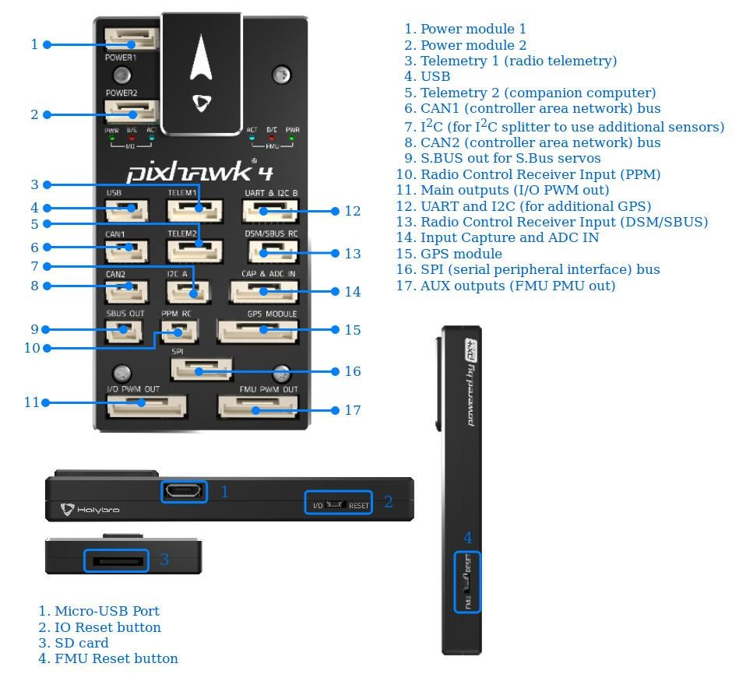

Figure 4.1 Pixhawk and its pins

(Source: www.docs.px4.io)

### Pixhawk Kit

We order S500 Pixhawk 4 holybro kit set that provides all the necessary electronics modules required for the complete automation. Figure 4.2 shows all the electronics modules that are listed below.

* 1 x Pixhawk 4 2.4.8 32-bit ARM Flight Controller with shell
* 1 x Shock Absorber for pix board
* 1 x Power Distribution Board (PDB)
* 1 x NEO-M8N GPS
* 1 x Pixhawk-I2C Splitter Expand Board
* 1 x 3DR radio Data Transmission Module (915mHZ)
* 1 x mini-USB cable
* 1 x GPS bracket
* 1 x SD adapter
* 1 x Telemetry module
* 1 x Buzzer
* 4 x Holybro BLDC motor
* 4 x 1045 Propellers
* 1 x S500 frame

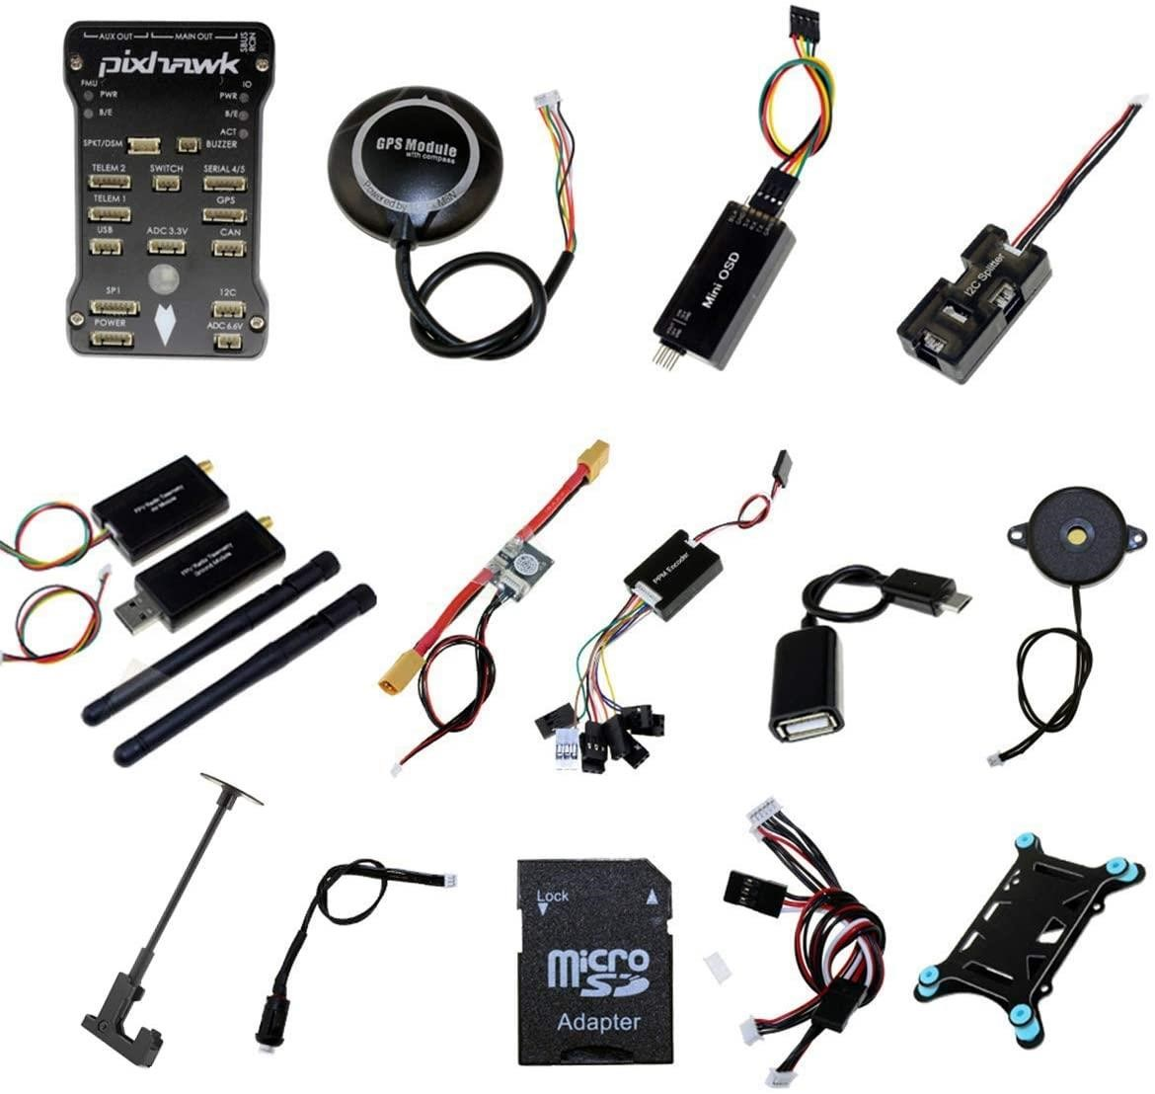

Figure 4.2 Pixhawk kits

(Source: www.docs.px4.io)

### FRAME

Drone frames are as important as the flight controller since the drone frames should meet the mechanical demand of the system. Our drone system must be able to carry all the payloads and should have enough space and mechanism to mount all the electronics components. Along with these requirements the drone frame needed to carry the gimbal and camera load and since we have a camera module, we need a landing gear too in order to protect the camera accessories. Suggestion from different online sites and tutorials we came to know about two such frames capable to meet our demand. They are F450 frame and S500 frame. We choose S500 Multi-Rotor Air PCB Frame as it is the up-gradation of the F450. Figure 4.3 shows a diagram of the S500 and its side measurement.

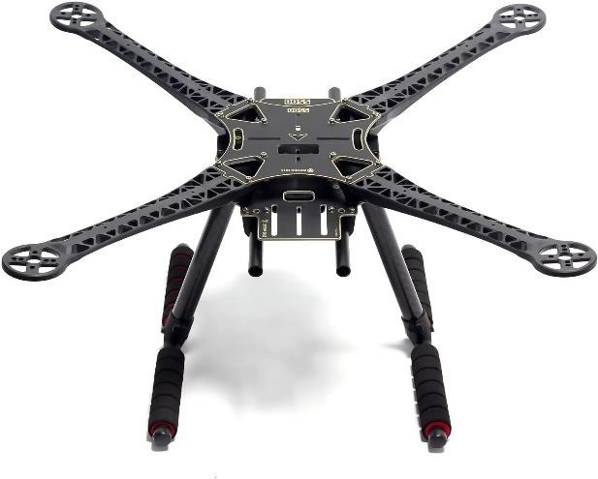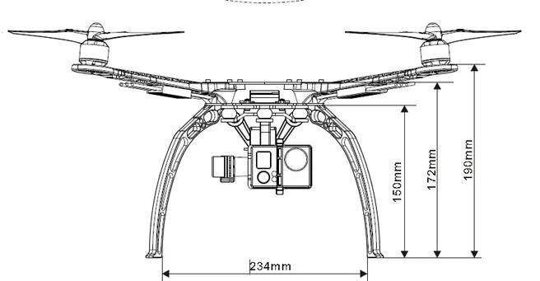

Figure 4.3 S500 and its side measurement

Following are the mechanical description of the S500 drone frame:

* Model: S500.
* Frame Weight: 405gm
* Wheelbase: 500 mm
* Motor Mounting Hole Dia.: 3 mm
* Landing Gear Material: ABS
* Arm Size: 220 x 40 mm
* Frame Material: Glass Fiber
* Landing Gear Length: 200mm

Recommendation for the S500 drone frame:

* Propeller: [“1045″ OR “8045” Orange Propeller (CW & CCW)](https://robu.in/product-category/multirotors/propellers/8-inch-to-10-inch/)
* Battery: [3S Orange Li-Po (1800 – 3600mAh)](https://robu.in/product-category/batteries/battery/lithium-polymer-li-po/3-cell-lipo-11-1v-12-6v/)
* ESC: [15A – 40A.](https://robu.in/product-category/multirotors/speed-contolleresc/)
* Motor: [800-1100 KV (brushless dc motor)](https://robu.in/product-category/multirotors/multirotor-motor/)

### BATTERY

The battery capacity use in the system usually depends on the average current drawn by the system. Battery is required to be light weighted and of higher mAh. Therefore, LiPo battery with high mAh was chosen as LiPo is light weighted and effective in constant-current discharge performance, power density and energy density [5]. Figure 4.4 shows typical LiPo Battery.

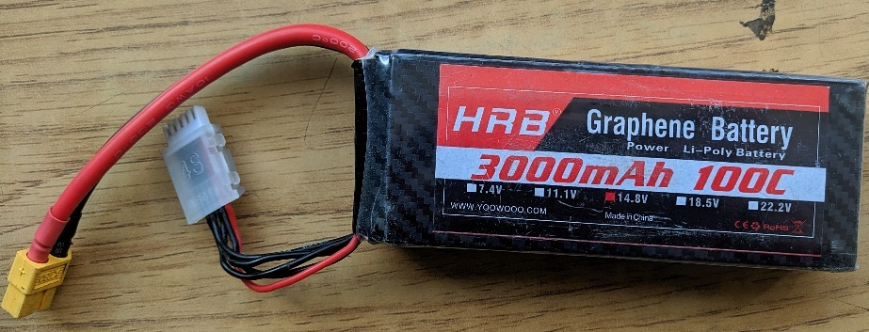

Figure 4.4 Lipo battery

### CHOOSING BATTERY CAPACITY

Choosing a battery needs its two different parameters to consider. First one is the battery voltage, and the second one is the battery capacity. Capacity uses C to denote amount of power that can be maximum obtained from the battery. Its unit is in milliampere hour (mAh) or Ampere hour (Ah). A battery having a 2000mAh means it can deliver constant current discharge of 2000mA for one hour. Value of C refers to the total discharge capacity. For example, 1C of 20mAh battery means 20mA of continuous current discharge, while 5C means 100mA of continuous current discharge.

Choosing the capacity of a battery for our drone operation we must know **calculation of time of flight** which can easily be calculated using equation (1).

|  |  |  |
| --- | --- | --- |
|  | $$Flight time in minutes=\frac{battery Amp hour(Ah) }{System current required(A)}×60$$ | (1) |

But as stated by the lipo battery guideline, it mustn’t completely discharge i.e., below 3.3 v each cell [6]. So. 4.2v as a cell full voltage of a cell, the effective discharge capacity of a cell is shown in equation (2) which simply we can only use approximately 78% of battery full capacity.

|  |  |  |
| --- | --- | --- |
|  | $$Effective battery capacity(EAh)=\frac{3.3}{4.2}×100\%=78.57\%$$ | (2) |

Thus, replacing battery Amp hour from equation (1) with the effective battery Amp hour (EAh) our final relation is represented in equation (3).

|  |  |  |
| --- | --- | --- |
|  | $$Flight time in minutes=\frac{EAh}{System current required(A)}×60$$ | (3) |

Now, considering a system draws 20 Amps of current at full throttle and we need a minimum time of flight up to 15 minutes, as it’s a sufficient time to photograph a small area of land. Using equation (3) we can say the effective battery capacity we needed is 5000mAh. Using equation (2), rated battery capacity is to be around 6000mAh. For more efficient time of flight, we have chosen a battery of 4S, 100C of 3000 mAh.

### BLDC MOTORS AND PROPELLERS

Brushless DC (BLDC) motors are the engine of a quadcopter. Motor is selected on the basis of KV rating. It is measured by the number of revolutions per minute (rpm) that a motor turns when 1V (one volt) is applied with no load attached to that motor. The KV rating of a brushless motor is the ratio of the motor’s unloaded rpm to the peak voltage on the wires connected to the coils. Thus, the RPM relation with KV and supply voltage is shown in equation (4).

|  |  |  |
| --- | --- | --- |
|  | $$RPM of the motor (RPM) =KV rating *Voltage input$$ | (4) |

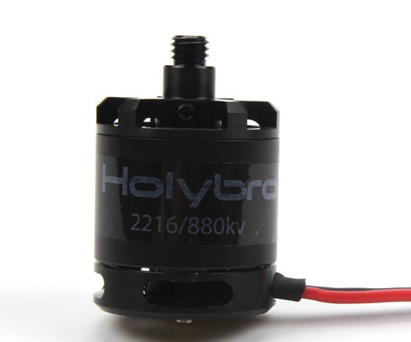

Figure 4.5 BLDC motor

(Source: www.holybro.com)

Similarly, propellers are the crucial part the drone flight as it turns motor’s rotary movement into straight downward thrust, which lifts the drone and counters the force of gravity. Propellers are selected on the basis of its diameter and pitch. Diameter of the propeller is the total circle that propeller makes during rotation in the air as shown in the figure (4.6) while pitch is the angle between the propeller blade chord line and the plane of rotation of the propeller. Pitch is often described in terms of units of distance that the propeller would move forward in one rotation assuming that there was no slippage as shown in figure (4.7).

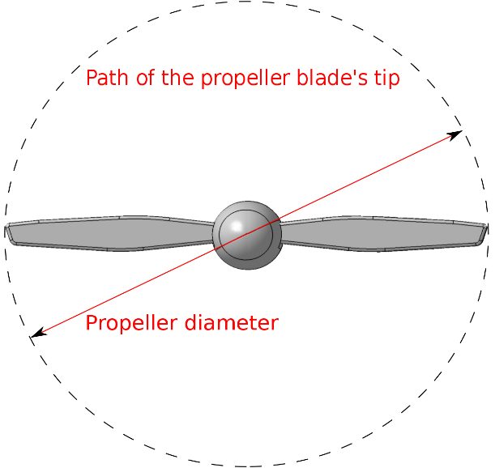

Figure 4.6 Propeller diameter

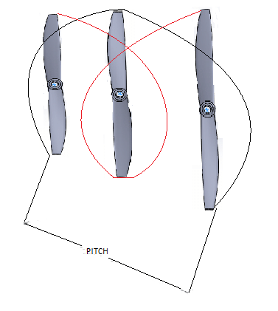

Figure 4.7 Propellor pitch

### THRUST ANALYSIS

The thrust generated by a drone must be equal or greater than twice than its weight [7]. The differential equations regarding aerodynamics propellors are complex. Creating, deriving, finding or relaying on a high accurate two blades propeller thrust equation applicable to all two blade propellors application isn’t easy. One may perform a bench test to analyze the thrust. However, there is an equation given by Gabrid Staples to calculate the thrust by two blades propellors [8] [9]. Equation (5) shows the Gabrid Staples equation.

|  |  |
| --- | --- |
| $$F=0.00000004392399×RPM×\frac{D^{3.5}}{\sqrt{P}}×\left[0.000423333×RPM×P-V_{O}\right]$$ | (5) |

Where,

F= Thrust in Newtons

RPM=Rotation per minute

D= Diameter of a propellor in inches

P= Pitch of a propellor in inches

Vo= Forward flight speed in m/s

S500 Pixhawk holybro kit has a BLDC motor with 980 KV rating along with a propellor rating as 1045 i.e., 10 inches in diameter and 4.5 inches as a pitch. Say a total weight of a drone is 2 kg, operating at 14.8V battery and acceleration due to gravity is 9.8 m/s2.

Considering VO=0 m/s,

Thrust needed by a drone to operate = 2*(2*9.8) = 39.2 N

Using, equation (4),

RPM of a single motor = 14504 rev/min.

Using, equation (5)

Thrust by a motor = 26.24011 N

Since there are four operating motors in a quadcopter (drone) so,

Total Thrust generated = 26.24011*4 = 104.960 N

Since total thrust generated is greater than the required needed thrust, therefore theoretically, drone is capable of lifting up at stationary.

### SPEED ANALYSIS

We now know that minimum total thrust we need is approximately 40N which will be be further distributed among four motors. Thus, the minimum thrust by each motor is about 10N in order to stay in air. Using equation (5), we can easily calculate the maximum theoretical forward speed of the drone which is found to be approximately 10 m/s.

### WEIGHT ANALYSIS

Considering the system flies at maximum speed i.e., at 9 m/s. At this speed the thrust generated by a single motor will be,

Using Equation (5),

Thrust by a single motor at 9 m/s =17.33 N

Total Thrust generated =17.33 *4 = 69.3369 N

Minimum Thrust Required = 39.2 N

Extra thrust generated = 69.3369-39.2 = 30.13969 N

Mass of extra Payload can be lift up = $\frac{2.0817}{9.8}$ =3.07547 kg

This shows that with 14.8 V power supply, it is suitable to add an extra payload like camera and gimble.

### ELECTRONIC SPEED CONTROLLER (ESC)

According to the Pixhawk document, it supports the ESC that supports a PWM input,

ESCs that use the ESC *One-shot* standard, UAVCAN ESCs, PCA9685 ESC (via I2C), and some UART ESCs (from Yuneec). Pixhawk does not support the D-shot protocol [10]. Generally, the ESC found in the market is 30A Simonk ESC but a review from many users shows that it has some major issues regarding stability and quick response failure. Furthermore, it needs a high calibration and has very low response. Therefore, we decided to go with ESC that uses better firmware than Simonk and supports the One-shot protocol as required by the Pixhawk flight controller. Pixhawk Holybro set provide an ESC that has One-shot firmware and has a quick response.

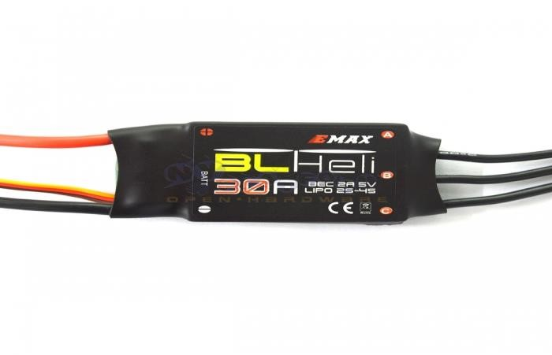

Figure 4.8 Electronics speed controller

(Source: www.holybro.com)

Details of ESC:

* Model: Oneshot.
* Burst Current: 40A (up to 10Sec).
* Input Voltage(V): up to 16V
* Constant Current: 30A.
* BEC: 5V /2A
* Suitable Batteries: 2 ~ 4S.

### RC RECEIVER AND TRANSMITTER

Pixhawksupport wide range of transmitter and receiver pair supporting s-bus radio transmission protocol. Radio transmitter gives us an additional controlling mechanism in order to ensure the safety and quick response from the ground control in case of any on air trouble. The remote has physical controls that can be used to specify vehicle movement (e.g., speed, direction, throttle, yaw, pitch, roll, etc.) and to enable autopilot flight mods (e.g., take-off, land, return to land, mission etc.). On *telemetry-enabled* RC systems, the remote-control unit can also receive and display information from the vehicle (e.g., battery level, flight mode). We used the RadioLink ATS9S TransmitterReceiver pair for our project.

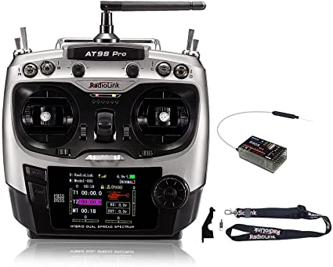

Figure 4.9 AT9S Pro radio transmitter

(Source:www.radiolink.com)

### CAMERA

This is the most crucial part of the entire selection process. Since the aim of our project is to generate 3D map, so the quality of the 3D map directly depends on the quality of the images and the orientation of the images of the area to be mapped. Therefore, our system must have a way to orient the camera at different angles as per required. In addition to these, a camera should be able to take the images at high quality (HD, UHD). For the project demonstration we decide to use GoPro camera to minimize the cost. The camera is fixed to S500 frame with the help of zip tie and the successive image is taken at 2 second of timelapse. This will simply enough to cover the 80% of overlapped images.

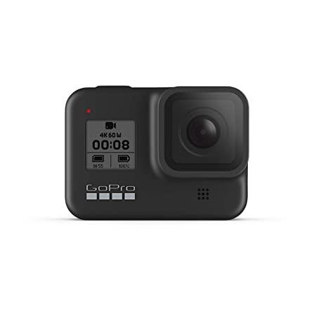

Figure 4.10 GoPro Camera

## SOFTWARE REQUIREMENTS

### MISSION PLANNER

Mission Planner is a ground control station for Plane, Copter and Rover. It is compatible with Windows only. Mission Planner (figure 11) is used as a configuration utility or as a dynamic control supplement for our autonomous vehicle. Mission Planner is a free, open-source, community-supported application developed by Michael Oborne.

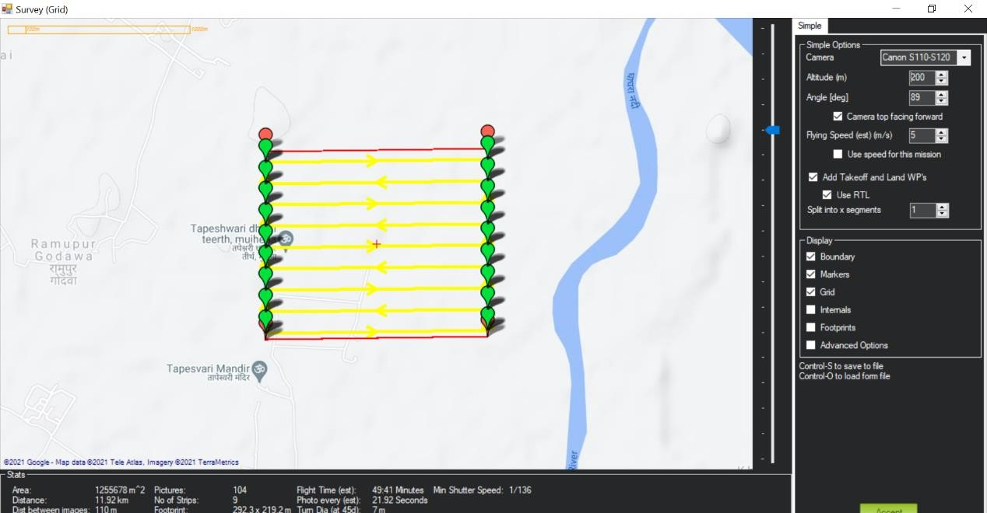

Figure 4.11 Mission Planner Survey Grid Example

We are using Mission Planner software in our project for following purpose.

1. Load firmware for quadcopter.

b. Set take-off points, landing point, pitch angle, altitude and so on.

1. Flight path planning.
2. Base station
3. Telemetry Control.

Figure shows a typical example of path planning using Mission Planner for survey.

### PIX4D

Pix4D is a Photogrammetry Software that will be used to process all the images captured by our camera to form a 3D model of the arena. Photogrammetry Software is a computer application that provides the tools for doing photogrammetric measurement. The loading of photos from camera, and the production of accurate measurements, diagrams, and models from those photos.

With photogrammetry, we are measuring and modelling the real world with a camera. Using this software, we can use camera like an advanced tape measure, diagramming tool, and 3d modeler all in one but we limit its use to formation of 3D model for our project.

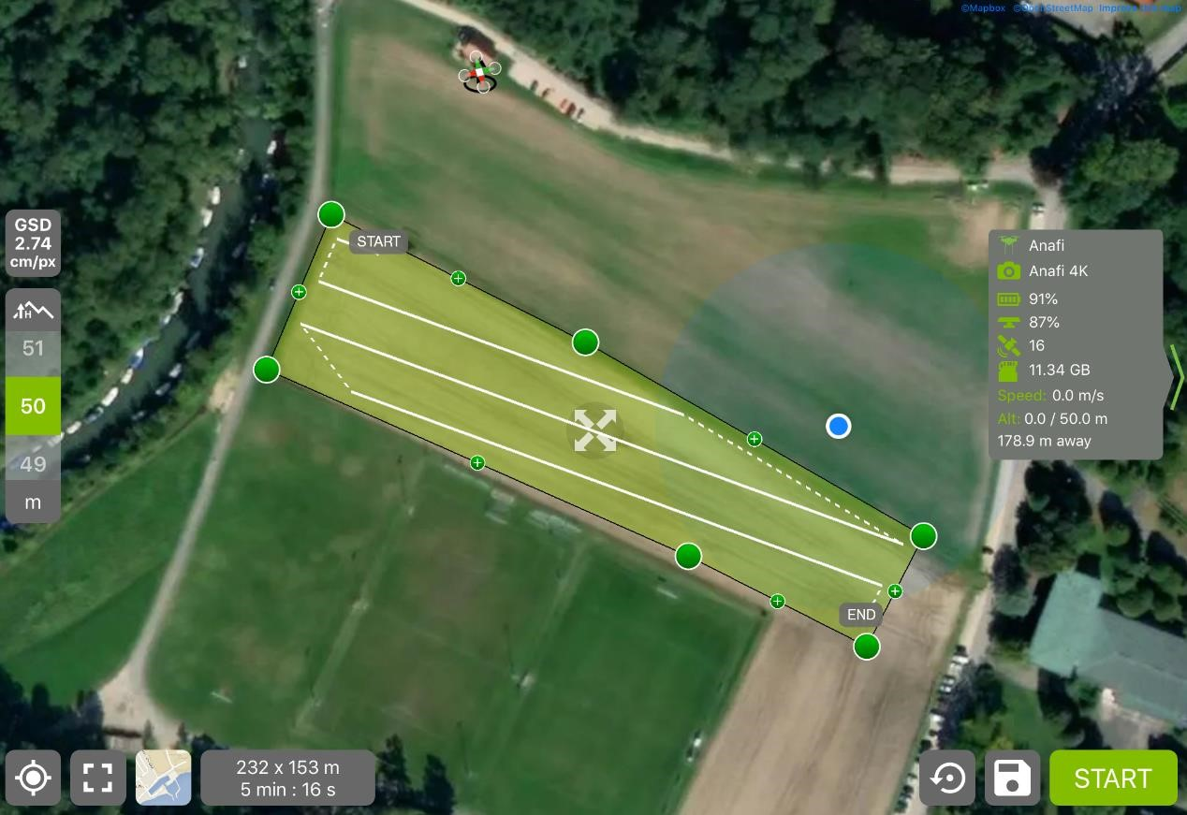

Figure 4.12 Screenshot of Pix4D interface

# SYSTEM DESIGN AND ARCHITECTURE

## MANUAL MODE

Figure 5.1 shows a system in a manual mode. At this mode it has two inputs. First one is the radio signal from the RC transmitter and the second is the power from battery. Radio signal receiver receive the signal and transmit it to the CPU where algorithm adjust the vehicle dynamics. The adjusted value is then transmitted to the ESC which control the speed and direction of the engine. Power Distribution Board (PDB) takes the power from battery and distribute it to the other parts of the system.



**Receiver**

**CPU**

**Vehicle**

**Dynamic**

**PDB**

**ESC**

**Motor**



**Radio**

**Signal**

**Power**



**Target**

Figure 5.1 System manual architecture

## AUTOPILOT MODE

Fig 5.2 shows the internal architecture of the autopilot system. It shows there are multiple components that works together to perform the tasks. The entire system will have two basic inputs. The first one is the mission targets that will be feed via mission planner software and the second will be the power input from 14.8v battery. Power Distribution board supply control voltage to entire autopilot system as well the other hardware like BLDC motors and sensors modules. Accelerometers control the speed of the drone in a control manner whereas internal compass along with gyroscope altitude sensors control Yaw and Pitch.

**GPS**

**Ʃ**

**Airspeed**

**Compass**

**Gyroscope**

**Altitudes**

**Ʃ**

**Ʃ**

**Ʃ**

**Acceleromete**

**r**

**GPS**

**Receiver**

**Power**

**Distribution**

**Board**

**Ʃ**



**CPU**

**Speed**

**and**

**Roll**

**Yaw**

**Pitch**

**Mission**

**Power**



Figure 5.2 Autopilot System Architecture

# METHODOLOGY

## DRONE DYNAMICS

According to the report by Charif Bennani Karim a drone has at least of 6 degree of freedom which can further be divided into two parts [11]. The first one is Barycentre and the movements around it. There are three barycentre movements named as three translation motions that make the quadcopter move longitudinally (forward and backward), vertically (upward and downward), and laterally (right and left). In addition, there are three rotation motions along three axes which make the drone move rotationally among each axis to produce roll, pitch, and yaw movements. These before mentioned motions when combined together generate what we call by the six degrees of freedom.

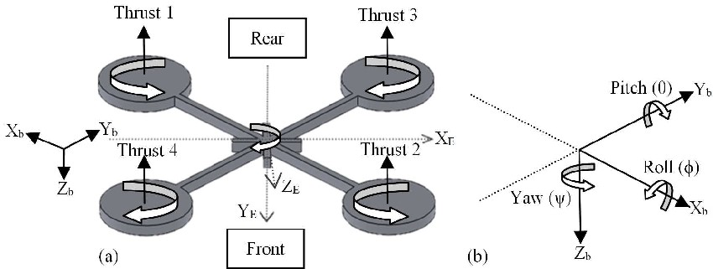

Figure 6.1 Structure of Drone and frame axis

(Source: “The design and development of general-purpose drone” Reference [11])

Figure 6.1 shows the structure of drone(a) and the description of the yaw, pitch and roll axis(b). The diagonal motors of the drone are rotated just opposite to each other to neglect the effect of torque produce by the motors. Moreover, the drone four basic movements which allows it to reach a certain attitude and height depending on each propeller’s speed of rotation are shown below along with their descriptions.

### THROTTLE MOVEMENT

This movement is provided by decreasing or increasing the speed of all the propellers with the same amount, which leads to a vertical force with respect to body frame that lowers or raises the drone. Figure 6.2 shows the throttle movement of the drone. The propellers speed Ω*i, i=*1,…,4 are equal to the in this case to Ω*k+*Δ*A* where Ω*k* is the constant minimum rotation speed of all motors and Δ*A* is a variable increased or decreased rotation speed.

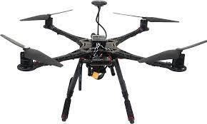

M1=Ω

*k*

*+*

Δ

*A*

M

3

=Ω

*k*

*+*

Δ

*A*

M

2

=Ω

*k*

*+*

Δ

*A*

M

4

=Ω

*k*

*+*

Δ

*A*



Figure 6.2 Throttle movement mechanism

### ROLL MOVEMENTS

This movement is produced by decreasing or increasing side motors speed as shown in the figure 6.3.



Figure 6.3 Roll movement mechanism

### PITCH MOVEMENTS

This movement is achieved by increasing or decreasing the speed of front and rear motors as shown in the figure 6.4. It helps to move drone forward or backward.

M1=Ω

*k*

*-*

Δ

*A*

M

2

=Ω

*k*

*-*

Δ

*A*

M

3

=Ω

*k*

*+*

Δ

*A*

M

4

=Ω

*k*

*+*

Δ

*A*



Figure 6.4 Pitch Movement mechanism

### YAW MOVEMENT

This movement is achieved by increasing or decreasing the rotational speed of diagonal motors as shown in the figure 6.5.

M

1

=Ω

*k*

*+*

Δ

*A*

M

4

=Ω

*k*

*+*

Δ

*A*

M

2

=Ω

*k*

*+*

Δ

*A*

M

3

=Ω

*k*

*+*

Δ

*A*



Figure 6.5 Yaw movement mechanism

## PIXHAWK CONTROL SYSTEM

Pixhawk is a powerful integrated hardware standard for open-source autopilot. It is to designed and programmed to accomplished high level of stability. However, for most of end user it’s not necessary to know the internal control architecture details that is ongoing inside the Pixhawk, according to the author Anton Erasmus in his lecture stated that Pixhawk has two sets of control system inside it [12]. The first one is the **Inner Controller** followed by the **Outer Controller**. Figure 6.6 shows the cascaded control architecture of the Pixhawk flight controller.

V

SP

A

SP

q

sp

Ω

s

∂T

sp

∂

R

s

∂

E

sp

∂

A

s

Ψ

sp

k

1

Hz

2

Hz

50

Hz

50

Position

Control

Velocit

y

Control

Acceleratio

n

And Yaw

to

Attitude

Angula

r Rate

Control

Angle

Control

M

I

X

E

R

P

PI

PID

P

X

SP

T

sp

Inertial Frame Body Frame

Figure 6.6 Pixhawk Cascade Control System

Here, Outer Controller receives a set point and generate command which serves as a set point for the inner controller. The inner controller then produces actuator command, the innermost controller is a Angular Rate Controller that receives a set point from Angle Controller and produce actuator commands that control the vertical velocity along with the aileron, elevator and rudder set points. These points later transferred to the Mixer, which produces the thrust set point for each motor. The control mechanism used here is the Proportional, Integration and Derivative (PID) control mechanism. In the cascaded control architecture, the angle controller receives angular set point (qsp) and command angular rate controller which is handle by the rate controller. Outside the angle controller here is a Velocity Controller that receives velocity set point and command Acceleration. This acceleration along with desired yaw angle is first converted to the attitude to send to the angle controller and a thrust to the mixture. The outermost part is the position controller that receives position set point and commands velocity. These all-control part works at a specific control rate and has a specific gain constant as shown in the figure above.

Ω

SP

Ω

∂sp

**Angular Rate Controller**

K

∫

𝜌

LP

𝜕

𝜕𝑡

D

K

P

+

−

+

+

−

Figure 6.7 Angular rate controller

Figure 6.7 shows the architecture of the angular rate controller. In the figure it is shown that the angular rate controller receives the angular set point and subtracted it with the angular velocity measurement to produce an error. The error further propagates through series of PID command to produce a command. This command is first saturated and finally virtual actuator command are obtained i.e., allerion, elevator and rudder. It has for gain control i.e., KPID. This is because there are two different implementations of PID control. First is the standard where P gain is set to 1 and K gain is known as the proportional constant while the second is the parallel form where K gain is set to 1 and P is known as the proportional constant. Here Integral form has form has a limit to avoid the integral windup and also to limit the control authority of the integration. Integral windup refers to the situation in the PID feedback control where a large change in set point occurs and the integral term accumulates a significant error during the rise (windup), thus overshooting and continuing to increase as this accumulated error is unwound[13]. Derivative term is computed from measurement and not the error. This is to eliminate the phenomena called derivative kick. Derivative kick occurs because the value of the error changes suddenly whenever the set point is adjusted. The derivative of a sudden jump in the error causes the derivative of the error to be instantaneously large and causes the controller output to saturate for one cycle at either an upper or lower bound [14].

2

Ω

SP

q

sp

q

q

e

q

oe

q

j

e

**Angle**

**Controller**

Error

Quaternio

Extract

Componen

Extract

Magnitud

Sg

n

×

Figure 6.8 Angle Controller

Pixhawk uses a Quaternion attitude representation rather than Euler angle representation. An attitude representation is defined as a set of coordinates that describe the orientation of a given reference frame with respect to a second reference frame [15]. This is done because of the singularity that exists at 90° pitch angle of the 3,2,1 euler representation which estimates the euler angle. Angle controller utilizes only proportional gain however it does have some non-linear parameters [16].

**Acceleration and Yaw to Attitude**

Here acceleration set point is converted to thrust in acceleration control function which later converted to attitude in getAttitudeSetpoint () function. Converted attitude set point is then transferred to the angle control.

Ω

SP

Ω

∂sp

**Velocity Controller**

∫

𝐼

LP

𝜕

𝜕𝑡

D

P

+

−

+

+

−

Figure 6.9 Velocity controller

Figure 6.9 shows the control architecture of the velocity controller. It is the implementation of the simple PID control. It prioritizes the vertical velocity rather than the horizontal velocity as tracking anti-wind mechanism is more important for stability.

Other control mechanism is similar to that of angular rate controller.

X

∂sp

XSP

K

+

−

Figure 6.10 Position controller

It is the simple proportional controller that limits the commanded velocity set point.

Figure 6.10 shows the control architecture of the position controller.

## COLLECTING OVERLAPPED IMAGES

This is one of the most crucial parts of the entire projects. Since thousands of images are needed to be taken in a very short span of time. It is required to have at least 60%70% of overlapped between images.

Authors Rushikesh Battular and his team in their paper suggested a simplifies mathematical calculation for taking successive overlapped images [17]. The size (*Lx*, *Ly*,) of the ground image taken by drone flying at height *h* above the ground depends on *h* and the size of the image sensor, as shown in figure 6.11.

𝐿𝑋 = 2ℎ 𝑡𝑎𝑛(𝛼/2) (6)

𝐿𝑌 = 𝐿𝑋/𝜌 (7)

where *LX* is the width of the image on the ground, *LY* is the length of the image on the ground, α is the angle of view of the camera, ρ is the aspect ratio (ρ = Ix/Iy ), Ix is the width of the image expressed in pixels, and Iy is the length of the image expressed in pixels.



L

Y



α

*h*

Figure 6.11 Camera projection

In addition, Ground Sampling Distance (GSD), which is the distance between centers of two pixels of an image measured on the ground is given by Equation (8).

|  |  |  |
| --- | --- | --- |
|  | $$GSD=\frac{L_{X}}{Ix }=\frac{2h tan(α/2)}{Ix }$$ | (6) |

From Equation (6), it can be concluded that the size of the image on the ground is directly proportional to the altitude of drone above the ground. Another important parameter is the proportion of overlapping between images along the length and width of the area. The industry-wide recommendation is to have 85% forward (length) overlap and 70% side (width) overlap. The distance between two overlapping images along the length and the width of an area of interest (Figure 6.12) can be determined as:

|  |  |  |
| --- | --- | --- |
|  | $$a=d×\left(1-\frac{q}{100}\right)$$ | (7) |

|  |  |  |
| --- | --- | --- |
|  |  | (8) |

where a is the distance between two images along with width of the mapping area, b is the is the distance of the two images along the length of the mapping area, d is the size of the image on the ground, p is the percentage of forward overlap, and q is the percentage of the side overlap.

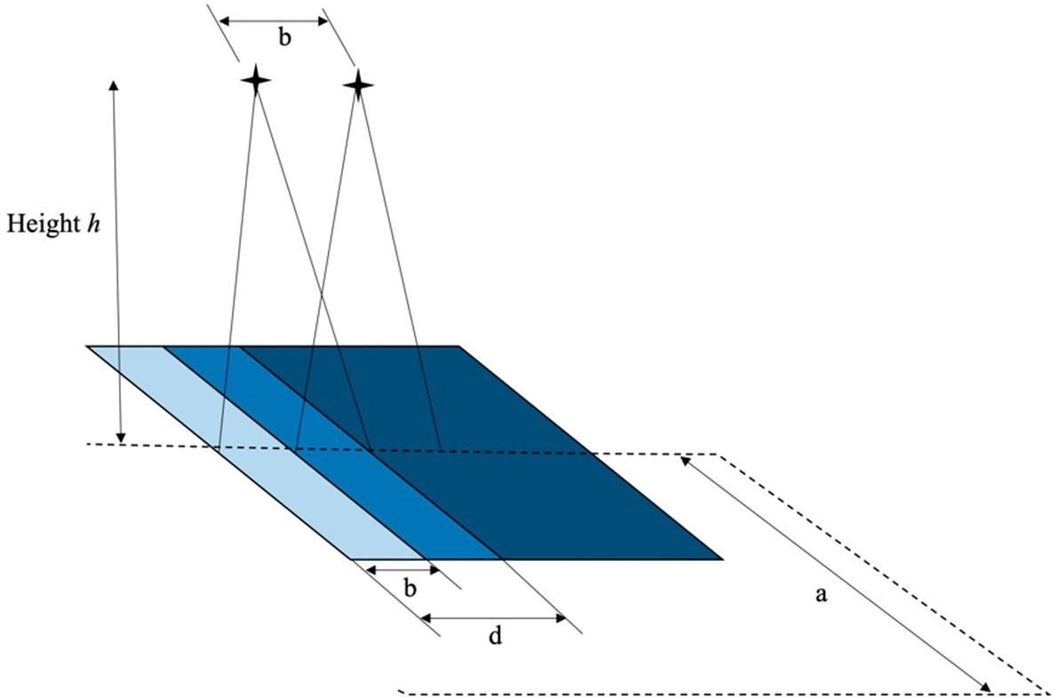

Figure 6.12 Flight parameters

(Source: Paper by R. Battulwar [17])

Thus equation (9) and equation (10) show at how much distance a drone is supposed to move forward in order to cover the required percentage of overlap.

## PHOTOGRAMMETRY MECHANISM

Photogrammetry uses methods from many disciplines, including [optics](https://en.wikipedia.org/wiki/Optics) and [projective geometry.](https://en.wikipedia.org/wiki/Projective_geometry) Digital image capturing and photogrammetric processing includes several well-defined stages, which allow the generation of 2D or 3D digital models of the object as an end product. The data model on the right shows what type of information can go into and come out of photogrammetric methods.

The 3Dcoordinates define the locations of object points in the [3D space.](https://en.wikipedia.org/wiki/Three-dimensional_space) The imagecoordinates define the locations of the object points' images on the film or an electronic imaging device. The [exterior orientation](https://en.wikipedia.org/wiki/Extrinsic_parameters) of a camera defines its location in space and its view direction. The [inner orientation](https://en.wikipedia.org/wiki/Intrinsic_parameters) defines the geometric parameters of the imaging process. This is primarily the focal length of the lens, but can also include the description of lens distortions. Further additionalobservations play an important role: With scalebars, basically a known distance of two points in space, or known fixpoints, the connection to the basic measuring units is created.

Each of the four main variables can be an input or an output of a photogrammetric method. Algorithms for photogrammetry typically attempt to minimize the sum of the [squares of errors](https://en.wikipedia.org/wiki/Least_squares) over the coordinates and relative displacements of the reference points. This minimization is known as [bundle adjustment](https://en.wikipedia.org/wiki/Bundle_adjustment) and is often performed using the [Levenberg–Marquardt algorithm.](https://en.wikipedia.org/wiki/Levenberg%E2%80%93Marquardt_algorithm) We don’t go in much detail of this algorithm as we will be using a ready to use 3D map generation software.

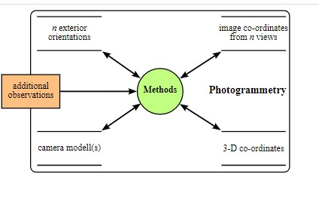

Figure 6.13 Data modelling of photogrammetry

# FLOWCHART

Overall operation can be classified into three main categories. First one is the drone automation i.e., flight controller loop, microcontroller operation and the third one is the photogrammetry operation in which 3D map is generated. Work flow of each operation is explained below:

## FLIGHT CONTROLLER LOOP

I

s

mapping

complete?

START

Get IMU Data

Fuse IMU Data

Get Desired Set point

from Flight Computer

Vehicle Response

PID Calculation

Control Mixing

Actuators Output

Stop

NO

YES

Figure 7.1 Flowchart of flight control loop

Figure 7.1 shows the Flowchart of the flight controller loop. As soon as the system activated and mission is set, it continuously looks for the mapping complete status. If its not completed it look for the system Inertial Measurement Unit (IMU) as well as the next set point. PID calculation calculates the error and correct them for the system stability. Control mixer receives all the corrected parameters and generate the required actuators for each motor. This actuator is used for the vehicle response.

## FLIGHT COMPUTER OPERATION

Stop

Get Sensor Data and Fuse

IMU Data

Interrupt Handler

Start

Estimate Odometry

Mission Planner

Controller Calculations

Send

Requests to Flight

Figure 7.2 Flowchart of flight computer operation

Figure 7.2 shows the overall CPU operation that starts with getting all the sensors inputs along with its current IMU data and fuse them together. Interrupt handler handles the internal or external interrupt generation during flight. Here, it triggers the camera as soon as the picture gets 60%-70% of overlapped with previous picture. Then the overall vehicle response is monitored in the estimate odometry section. It includes velocity, thrust, pitch, roll angle and so on. Infusing the system with mission provided with mission planner it performs necessary control calculation required for stable flight which is explained in the above sections.

## PIX4D APPROACH

Figure 7.3 shows the data processing procedure used by the Pix4D software to generate a 3d map.

Start

Original images

Key

point extraction

(

)

image by image

Automatic Aerial

Triangulation (AAT)

Automatic tie points

D point cloud

3

densification

Orthomosaic image

and DSM generation

Stop

Figure 7.3 System approach by Pix4D

# IMPLEMENTATION AND TESTING

The overall project is divided into four stages.

* Assembly and calibration
* Manual flight Test
* Auto flight test
* Auto flight test with Picture intake and 3D map generation

## ASSEMBLY AND CALIBRATION

We receive all of our components in the beginning of the September 2020. After a quick assembly as guided by the holybro S500 V2 and Pixhawk 4 user guide, we assembled our S500 Pixhawk drone [18]. The glimpse of the components and drone parts are shown in the figure 8.1. Figure 8.2 and figure 8.3 shows the required circuit diagram and a drone after completely assemble.

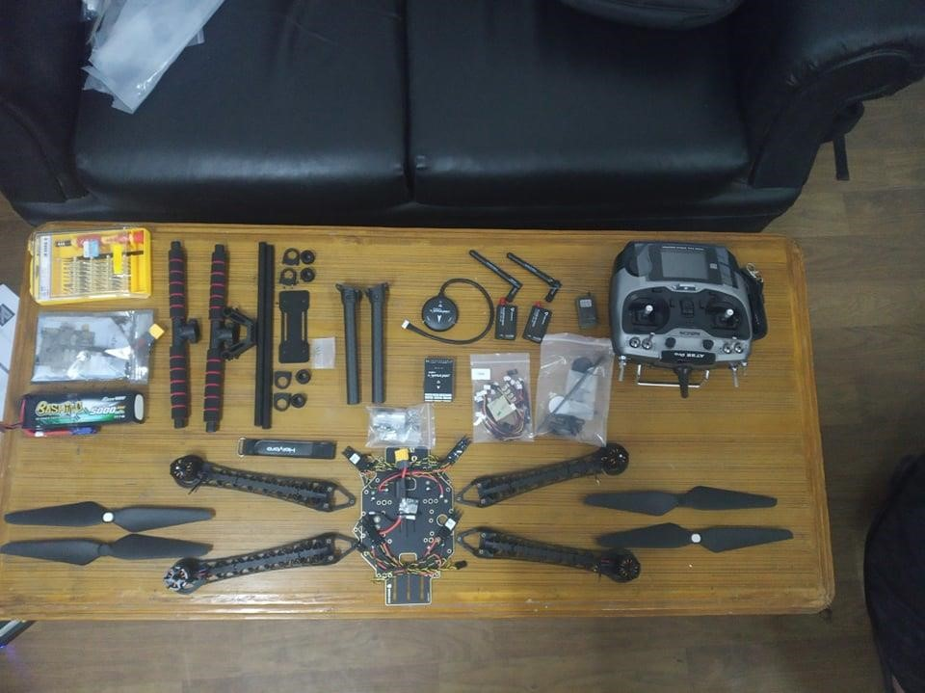

Figure 8.1 S500 holybro Pixhawk kit

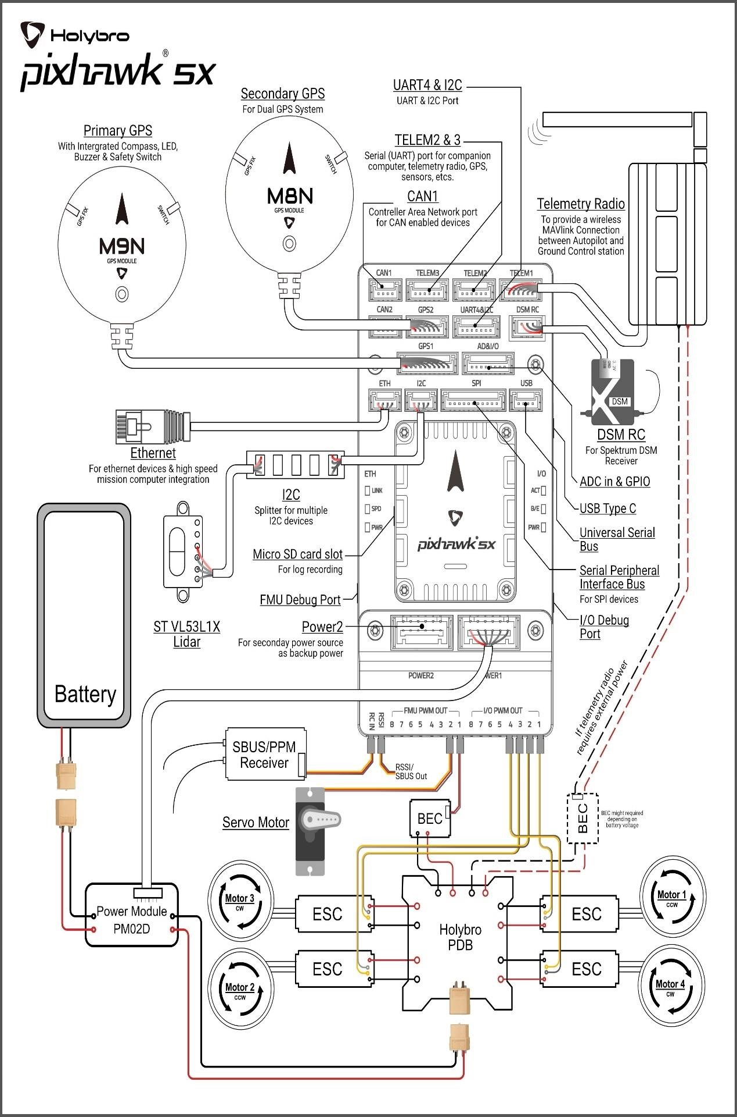

Figure 8.2 Circuit diagram of system

(Source: www.holybro.com)

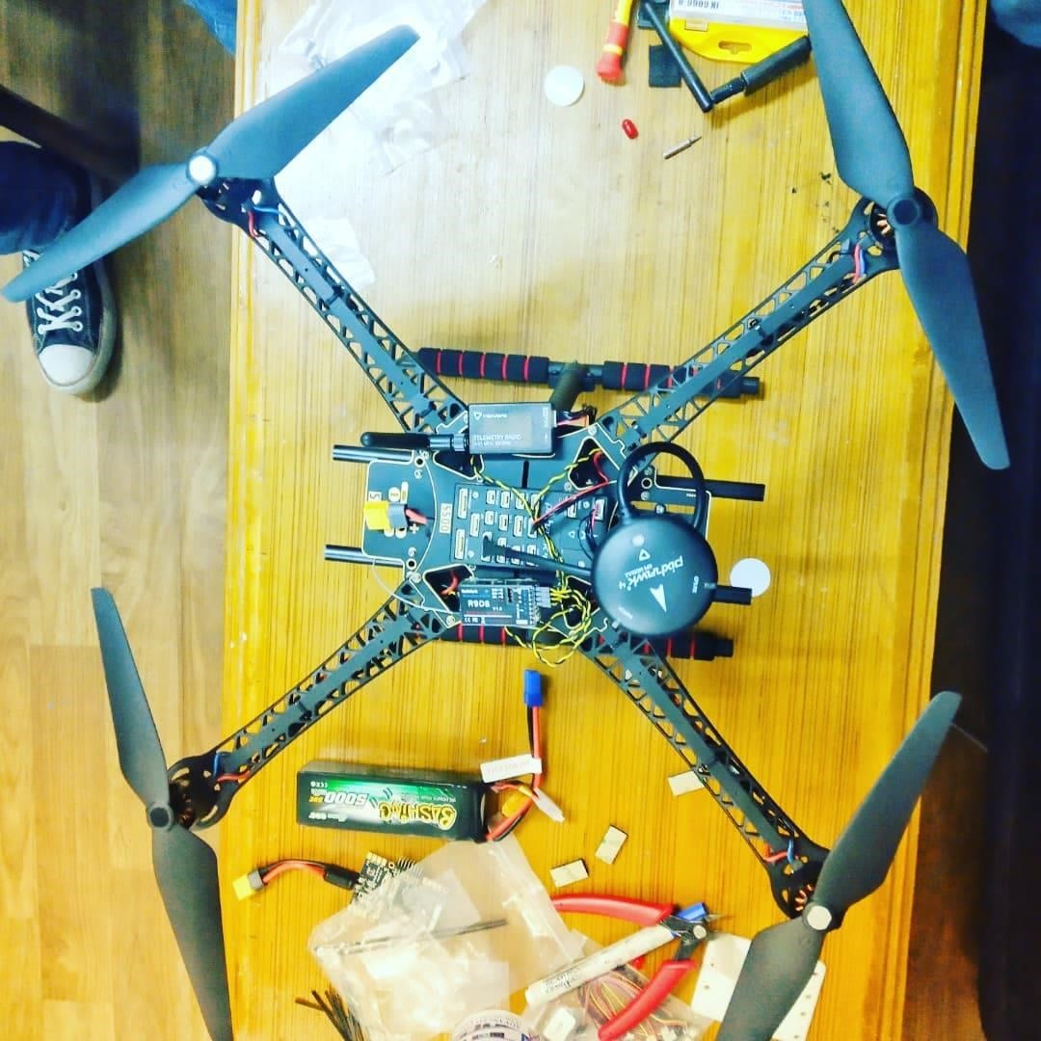

Figure 8.3 Drone after assembly

Things to be care while assembly:

* Every component is to be solder properly and neatly.
* S500 has a wide space for the component’s placement, however proper components management is essential to balance the weight.
* Thrice check the connection before power supply as the electronic components are very sensitive and mis-wiring can lead to sever damage.
* Proper manual instruction knowledge is essential to debug the problem.

### PROGRAMMING AND CALIBRATION

Once the assembly is done, we need go through the basic programming and calibration required for the system operation. We make a use of Mission Planer software. Figure 8.4 shows “Heads-Up Display (HUD)” i.e., a home screen of Mission Planner ground stations.

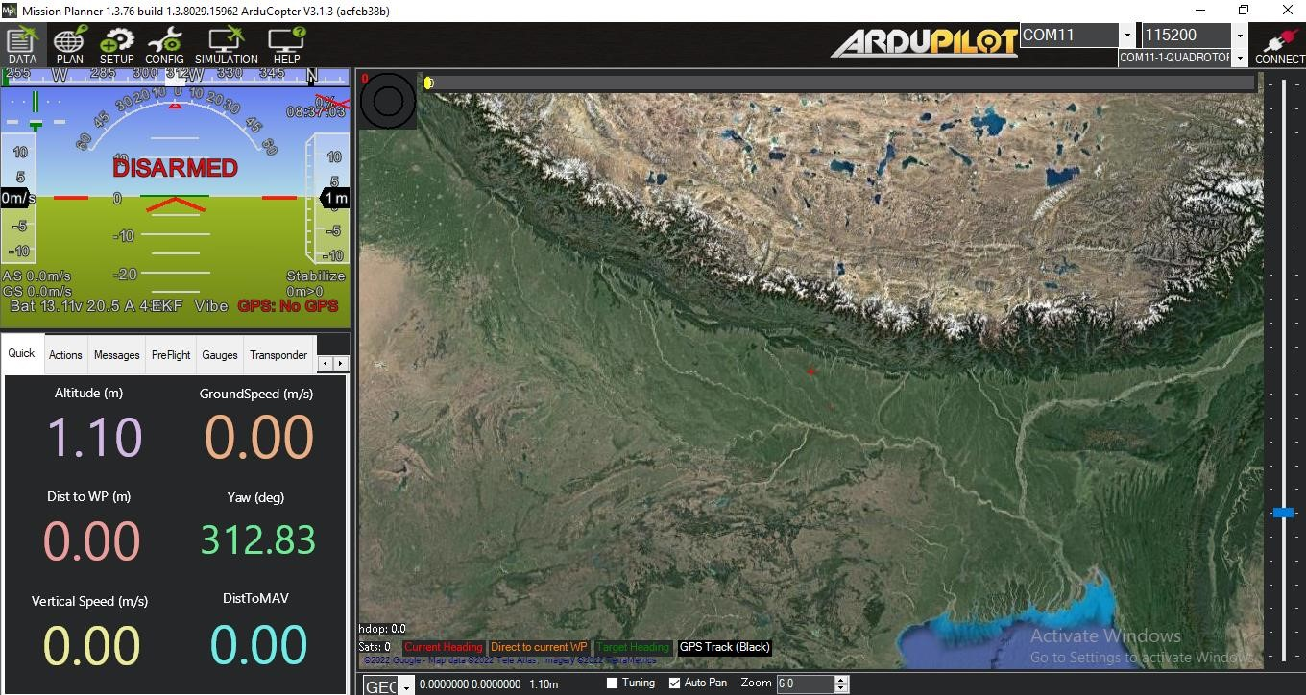

Figure 8.4 Screenshot of home screen of Mission planner

The HUD of the mission planner can be divided into five sections. Section 1 as shown in the figure 8.5 shows the flight status dialogue box, once connected via telemetry. Its functions are labelled below in table 1.

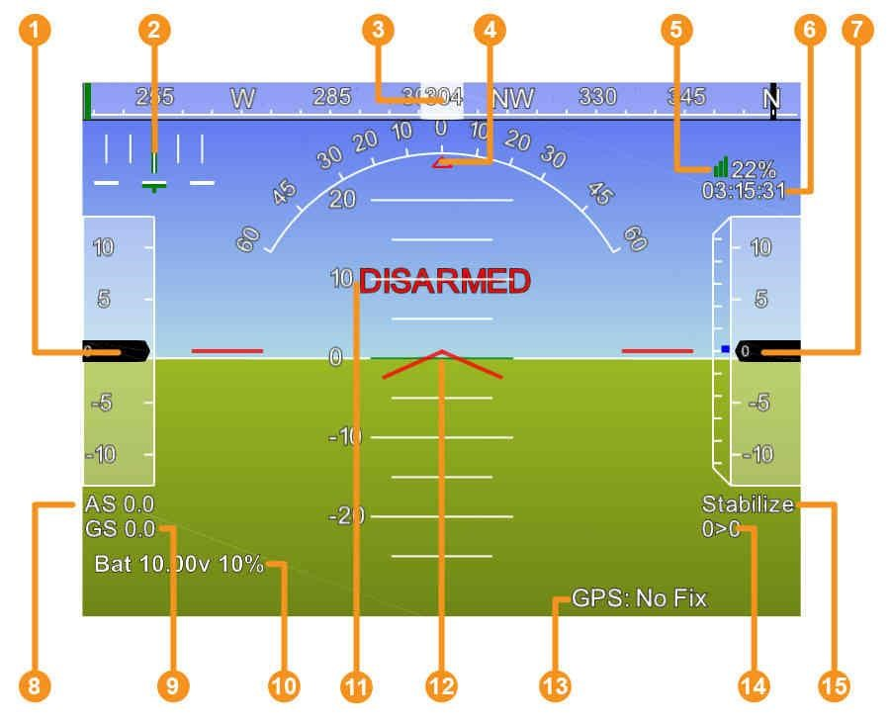

Figure 8.5 Flight Status dialogue box

(Source: www.ardupilot.com)

|  |  |
| --- | --- |
| **Numbers** | **Function** |
| 1 | Air speed (Ground speed if no airspeed sensor is fitted) |
| 2 | Cross track error and turn rate (T) |
| 3 | Heading direction |
| 4 | Bank angle |
| 5 | Telemetry connection link quality (averaged percentage of good packets) |
| 6 | GPS time |
| 7 | Altitude (blue bar is rate of climb) |
| 8 | Air Speed |
| 9 | Ground Speed |
| 10 | Battery status |
| 11 | Artificial Horizon |
| 12 | Artificial Attitude |
| 13 | GPS Status |
| 14 | Distance to Waypoint >Current Waypoint Number |
| 15 | Current Flight Mode |

**Table 8.1 Assigned function for flight status dialogue box**

Similarly, second section is the Flight connection section as shown in the figure 36 which includes the com port selection option to connect Pixhawk flight controller with mission planner via USB cable or telemetry.Recommended baud rate for Serial Communication is 115200 bits per second and for telemetry connection is 57600 bits per second

The third section includes flight configuration section as shown in the figure 8.2. The role of each of its parts are explained in the table 8.2.

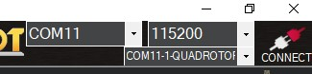

Figure 8.6 Flight Connection Section



Figure 8.7 Flight Configuration section

|  |  |
| --- | --- |
| **Section Parts** | **Function** |
| Data | Shows the current flight data logs and operation details |
| Plan | Use to plan the flight paths and operation |
| Setup | Use to install and update firmware, setup and calibrate mandatory and additional hardware’s. |
| Configuration | It allows to manually configure the parameters list. |
| Simulation | Simulate the flight path planning |
| Help | Help section |

**Table 8.2 Details of Flight configuration section**

The fourth section is the flight control and log section as shown in the figure 8.8. It has two parts, the upper parts used to control the flight, record and access the flight logs while the lower parts display the flight parameters details and status including Altitude, Ground Speed, Yaw, Vertical speed, distance to waypoint, and distance to mavlink. Only few functions of the full capacity of the pixhawk and mission planner are used in this project.

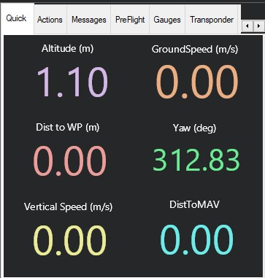

Upper part

Lower part

Figure 8.8 Flight control and status section

The fifth section is the map area on the right side of the flight data screen displays as shown in the figure 8.9. It displays the vehicles track as it moves, provides other information and allows to enter some control actions which send commands to the vehicle via telemetry. It is recommended to go through the list of control commands and necessary guideline before operation [19].

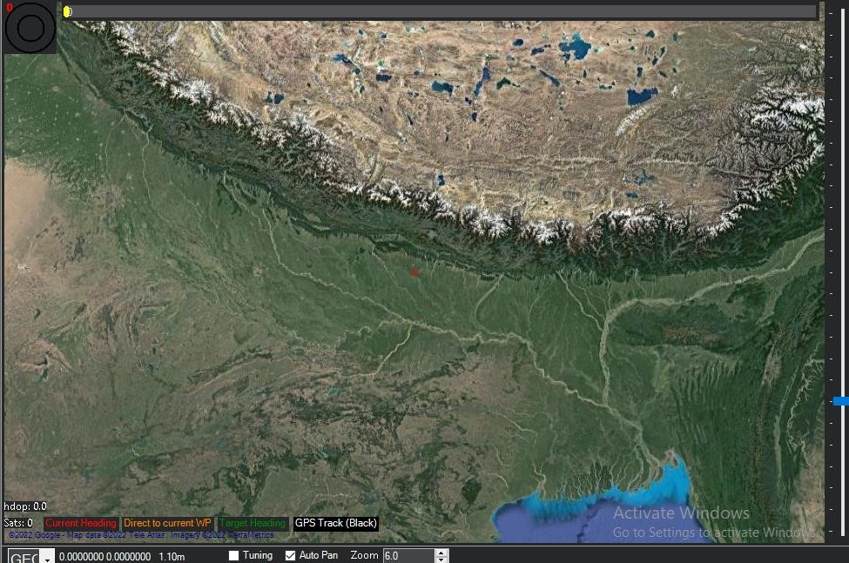

Figure 8.9 Map area

To programmed and calibrate following steps were taken:

**Step 1:** Connecting the pixhawk flight controller with the computer either by using telemetry or by USB cable.

**Step 2:** Opened the **Setup section** and disconnected the mavlink connection (keeping the physical connection as it is) and then the firmware was installed for the flight controller according to the frame we are using. Since, we are using a Quadcopter frame with X structure, we choose it and complete the firmware installation process as shown in the figure 8.10.

**Step 3:** The mavlink connection was then established once the firmware was installed.

Install

firmware

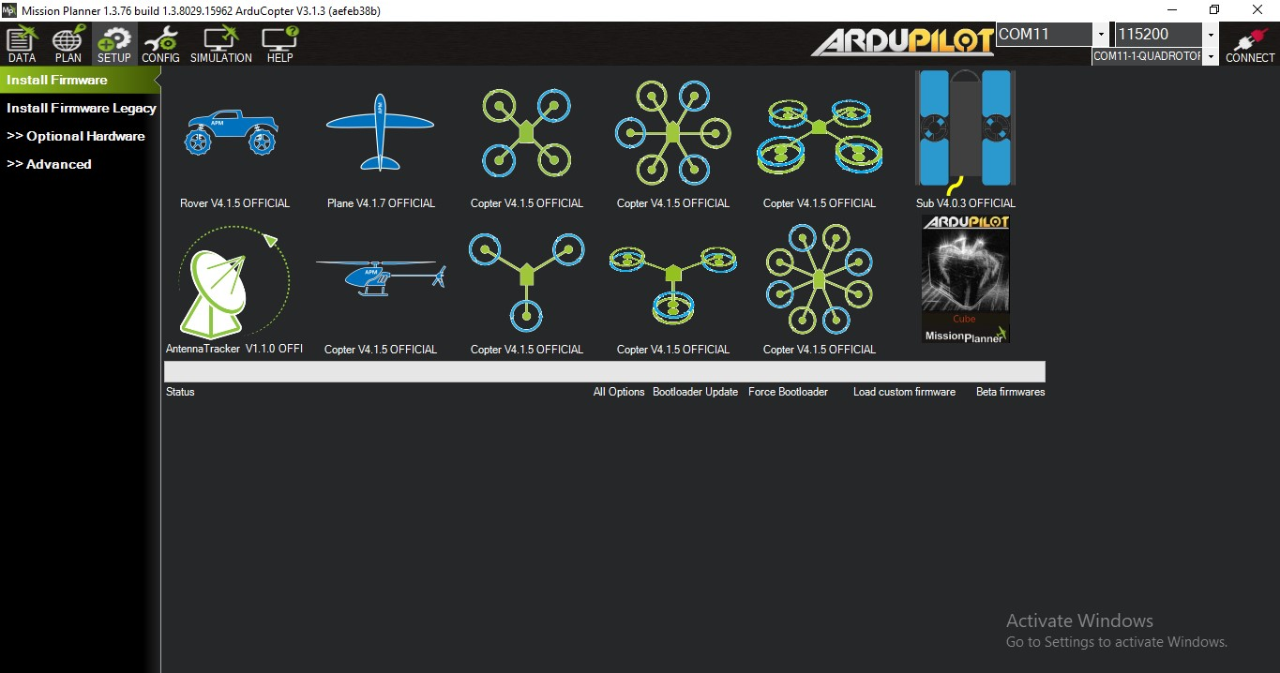

Setup Section



Firmware of X

-

shape

Quadcopter firmware



Disconnect

MavLink

keeping

connection as it

is



Figure 8.10 Installing firmware process

A new option called “Mandatory Hardware” appeared on the left side of the screen as soon as the mavlink connection is established (figure 8.11). This section includes all the necessary calibration including Frame type, Acceleration calibration, Compass calibration, Radio calibration, Flight modes, GPS and so on. Once the calibration is done, a drone is now ready to perform its first operation.

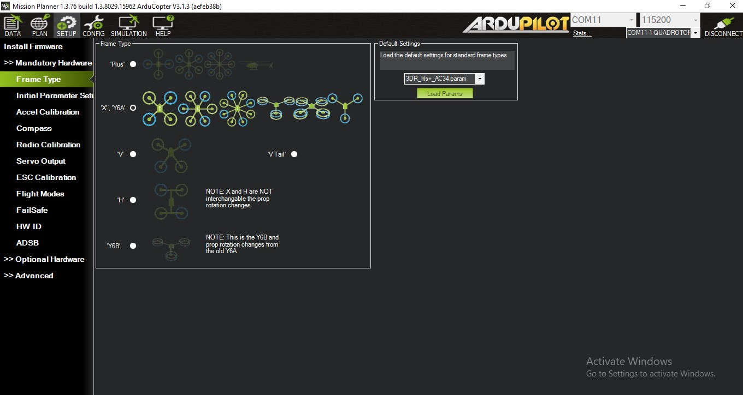

Establishment of

Mavlink connection



Mandatory hardware calibration

Figure 8.11 Mandatory hardware calibration

## MANUAL FLIGHT TEST

Our work strategy for the proper manual testing is shown in the figure 8.12. The manual testing was done on the college premises. At first, we carefully check every circuit connection and then necessary manoeuvres were tested before applying a sufficient throttle. After concluding the suitable external environment, we tested out the flight at very low altitude in order to avoid the possible risk.

STEP 1

STEP 2

STEP 3

Checking

necessary

maneuvers

Throttle, pitch,

(

yaw)

Checking

external

factors

(

climate, air

speed,

moisture)

Flight

operation (Take

off, Hold in air,

movement and

landing)

Figure 8.12 Manual testing approach

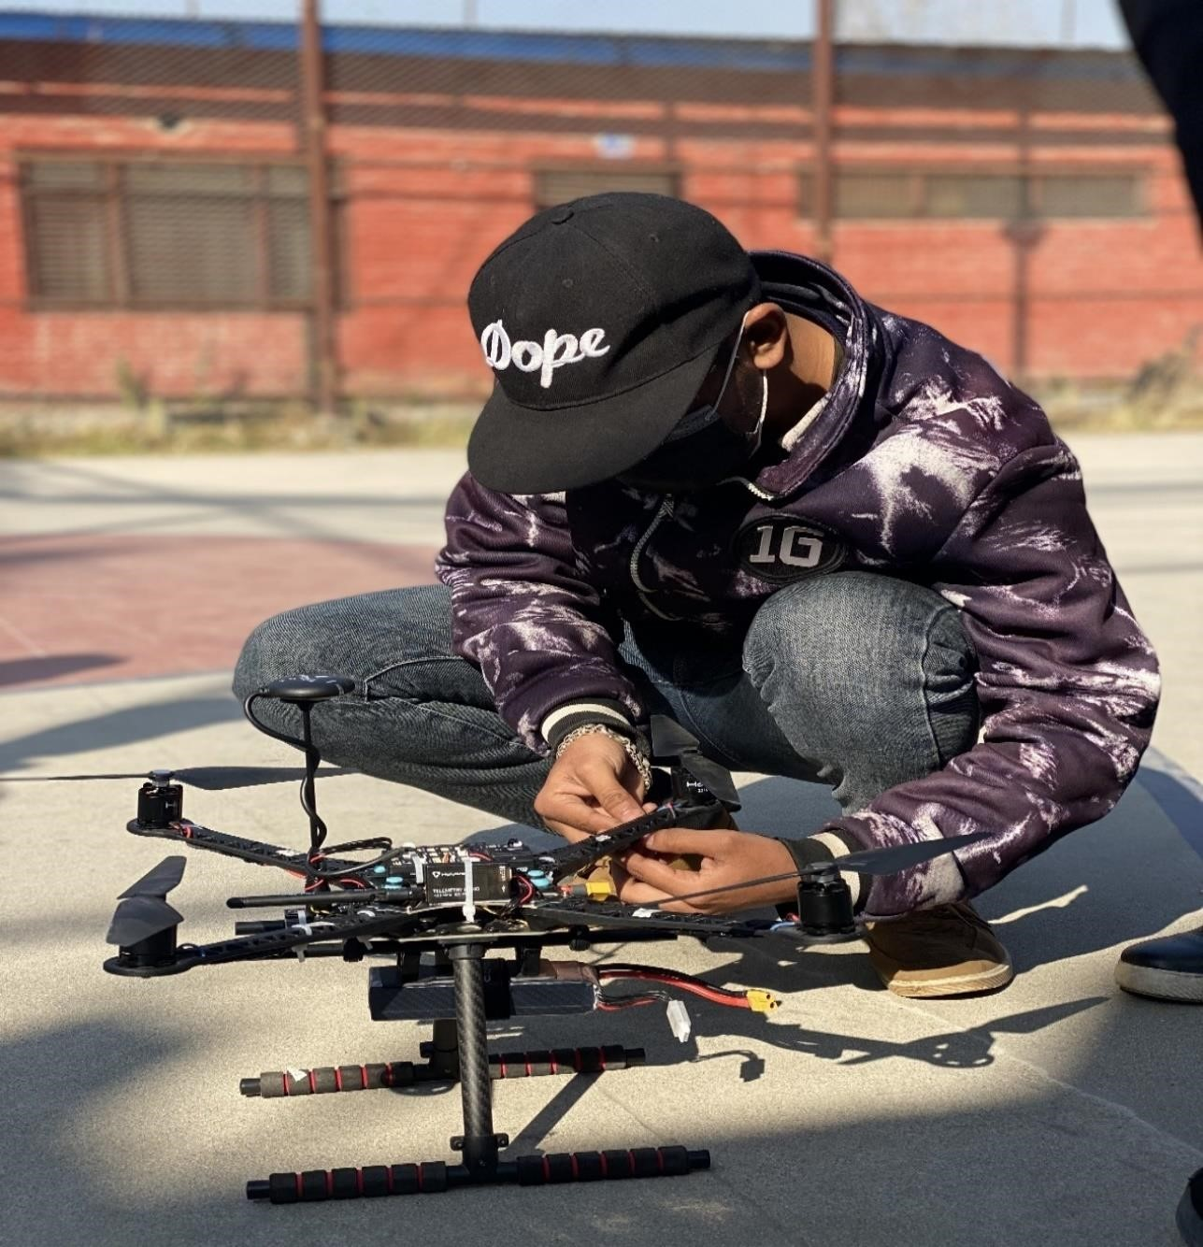

Figure 8.13 Member setting up drone before operation

**Test Result**

In the initial flight, we faced some problem with the system stability, the reason behind it was the fault in PID calibration. After some more precise calibration we easily achieved the control over drone and the flight was found to work perfectly.

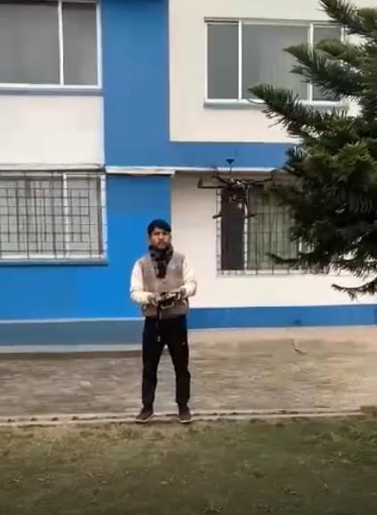

Figure 8.14 Member operating in a manual mode

## Auto flight test

This section explains about the approaches we performed to carried out the automation test. Since this section is the cruel part of entire projects as taking the aerial photography is completely depending in the system stability. There are different control modes provided by the Pixhawk flight controller which can be study in the pixhawk manual guide. Some important modes used in our system are discussed in the table 8.3.

|  |  |
| --- | --- |
| **Flight Modes** | **Description** |
| Stable | Keep drone stable using GPS data and the sensor on the board |
| Altitude Hold | Hold at the set altitude without considering the air flow |
| Loiter | Maintained the set position (air flow is considered and the system set itself by adjusting the motor speed and orientation) |
| Land | Land a drone slowly and safely |
| RTL | Return to land i.e., at a base station |
| Failsafe | Monitor battery percentage and connection with ground station.  Activate RTL mode in case of low battery and loss connection. |

**Table 8.3 Flight control modes**

We carried out automation test in three phases. Figure 8.4 shows our automation test plan.

Figure 8.5 shows our test cycle. It can be seen that the test cycle goes through a debugging process whenever a bug is detected. If necessary, the previous test is repeated.

TEST 1

TEST 2

TEST 3

*.*

Auto

takeoff

+

Altitude

hold mode

+

Land

mode

Loiter

mode

+

RTL

mode

+

Fail safe

mode

Mission

assigned

Figure 8.15 Phases of automation test

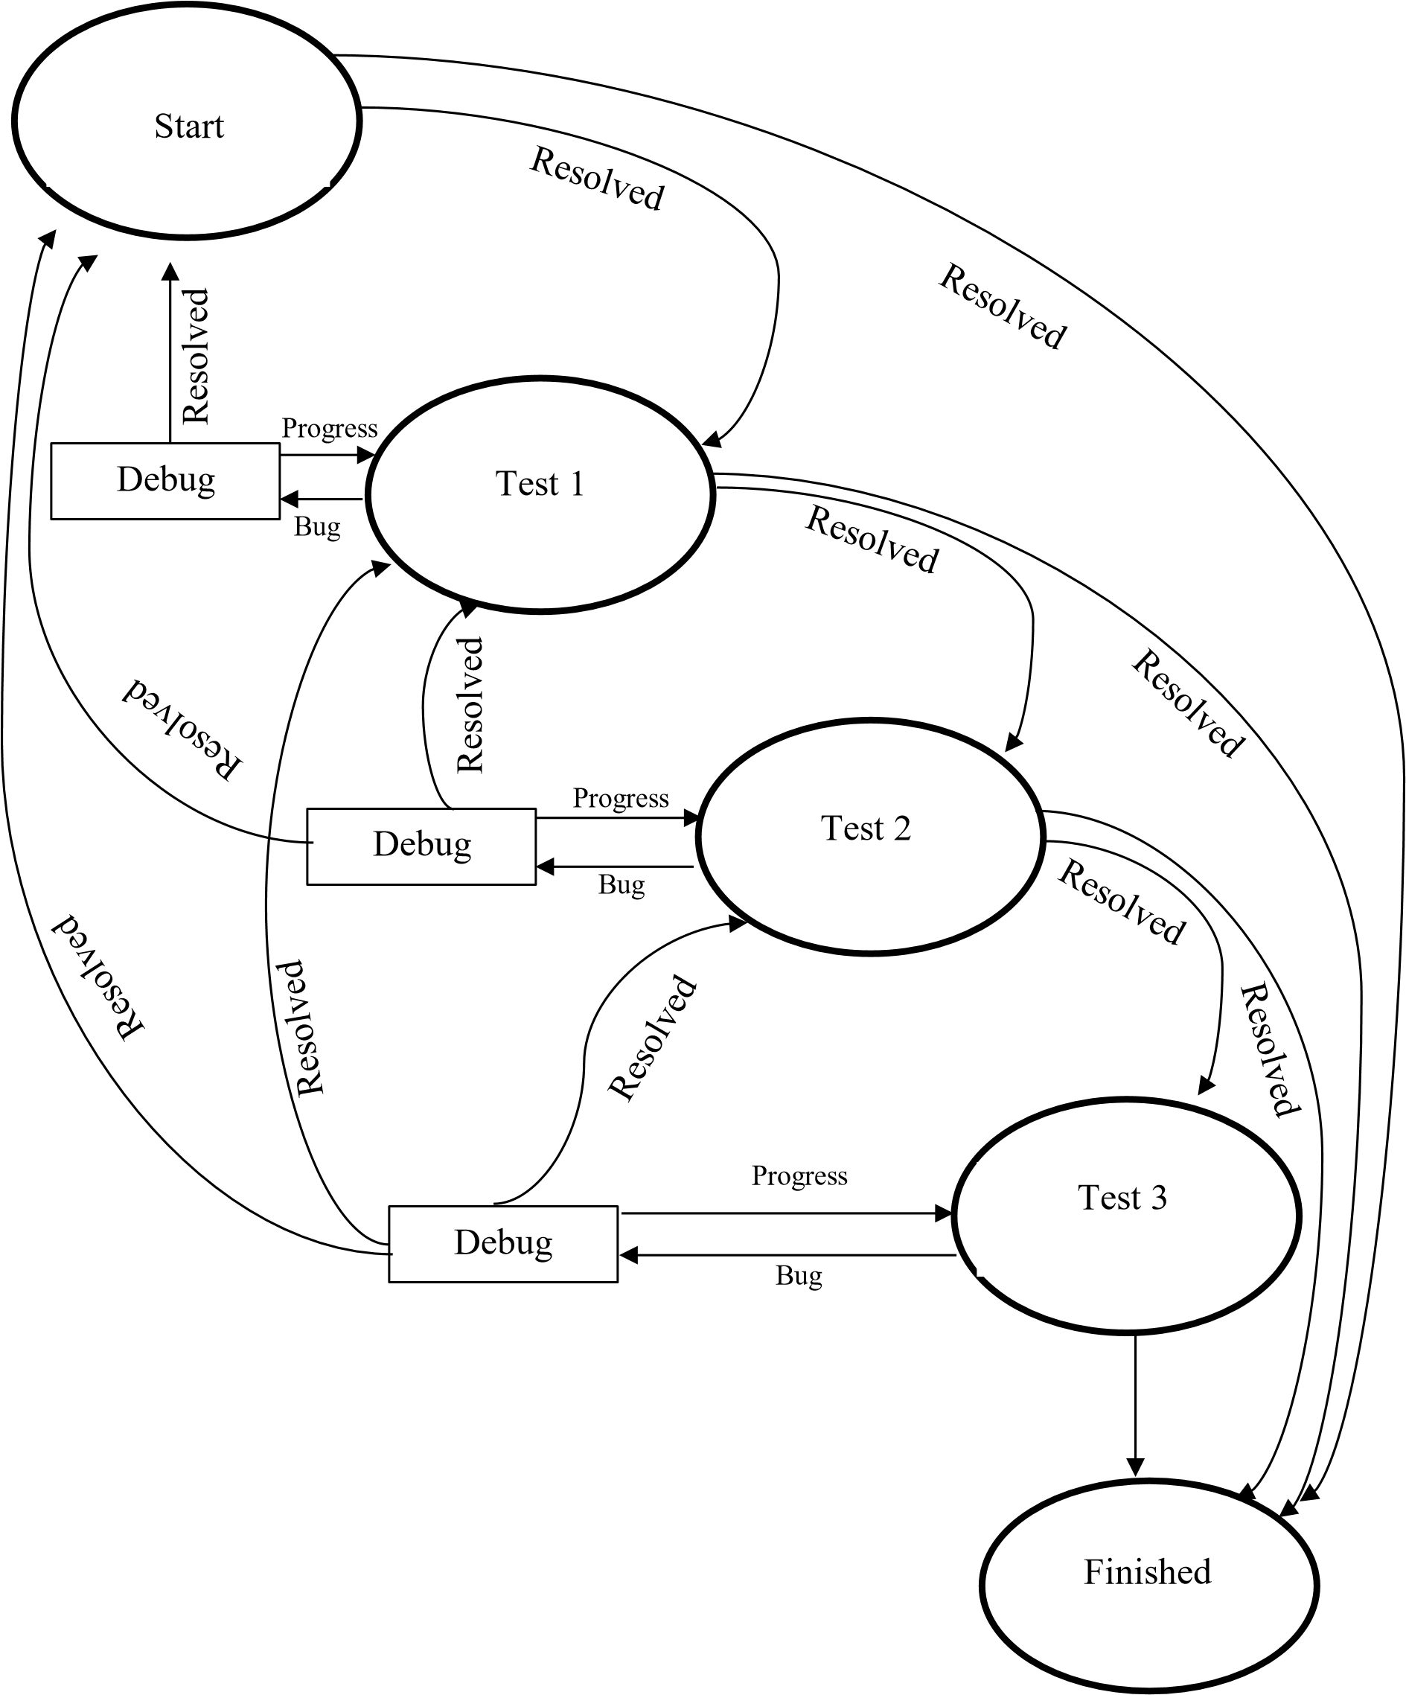

Figure 8.16 Test cycle

### TEST 1

**Test Objective**: Auto Take-Off, Altitude Hold Mode and Auto Land Mode.

**Test Premises:** Tribhuvan University open field

**Test Approach:**

Step 1: Start

Step 2: Start Ascending

Step 3: Is set altitude achieved?

Yes: Go to step 4

No: Go to step 2

Step 4: Hold the altitude

Step 5: Is set altitude hold time achieved?

Yes: Go to step 6

No: Go to step 4

Step 6: Start Descending

Step 7: Stop

**Test Result:**

|  |  |  |  |  |  |
| --- | --- | --- | --- | --- | --- |
| **Operation** | **Repeat**  **Cycle** | **Passed**  **Cycle** | **Failed**  **Cycle** | **Overall**  **Status** | **Remarks** |
| Auto takeoff Mode | 2 | 2 | 0 | Pass | No severe fault noticed |
| Altitude  Hold Mode | 2 | 2 | 0 | Pass | No severe fault noticed |
| Land Mode | 2 | 2 | 0 | Pass | No severe fault noticed |

Table 8.4 Automation test result of phase 1

Repeat Cycle =Number of times the operation is tested

Passed Cycle= Number of times the operation is passed

Failed Cycle= Number of times the operation is failed

**Precautions:**

* Checked and verified the circuit connection before supplying the power to the board
* Ensured the Battery is fully charged
* Manually checked the thrust, yaw and roll maneuvers to ensure the motors and ESC working properly before activating automation.
* Experience member always on a ready approached to take manual control whenever the things go wrong
* External factors:

Temperature: 20°C -25°C

Wind Speed: Normal

Weather: Sunny, clear sky

**CONCLUSION AND FINDING**

* Altitude Hold Mode do not take external wind speed into calculation and is found to be slightly varied in a wind direction while maintaining the precise altitude.
* The drone precisely maintained its altitude over set time period.
* The distance moved by the drone was neglible while maintaining the altitude.

### TEST 2

**Test Objective**: Auto Take-Off, Loiter Mode and Return to Land Mode.

**Test Premises:** Tribhuvan University open field.

**Test Approach:**

Step 1: Start

Step 2: Start Ascending

Step 3: Is set altitude achieved?

Yes: Go to step 4

No: Go to step 2

Step 4: Hold the altitude

Step 5: Is set altitude hold time achieved?

Yes: Go to step 6

No: Go to step 4

Step 6: Start Descending

Step 7: Stop

#### Test Results

|  |  |  |  |  |  |
| --- | --- | --- | --- | --- | --- |
| **Operation** | **Repeat**  **Cycle** | **Passed**  **Cycle** | **Failed**  **Cycle** | **Overall**  **Status** | **Remarks** |
| Auto takeoff Mode | 2 | 2 | 0 | Pass | No severe fault noticed |
| Loiter  Mode | 2 | 2 | 0 | Pass | No severe fault noticed |
| Land Mode | 2 | 2 | 0 | Pass | No severe fault noticed |

Table 8.5 Automation test result for phase 2

**Precautions:**

* Checked and verified the circuit connection before supplying the power to the board
* Ensured the Battery is fully charged
* Manually checked the thrust, yaw and roll maneuvers to ensure the motors and ESC working properly before activating automation.
* Experience member always on a ready approached to take manual control whenever the things go wrong
* External factors:

Temperature: between 20°C to 25°C

Wind Speed: Normal

Weather: Sunny, clear sky

**Conclusion and findings**

* Loiter Mode do takes external wind speed into calculation and is found to precisely hold the position without any horizontal movement.
* The drone precisely maintained its altitude over set time period.
* The distance moved by the drone was almost negligible.

### TEST 3

**Test Objective**: Mission Assigned i.e., waypoints are provided and once all the path waypoints are achieved drone activates RTL point.

**Test Premises:** Tribhuvan University open field.

**Test Approach:**

Step 1: Start

Step 2: Load mission plan (figure (assigned pathway))

Step 3: Start mission

Step 4: Fetched next waypoint

Step 5: Reach at the fetched waypoint

Step 6: Is all waypoints completed?

Yes: Go to step 7

No: Go to step 4

Step 7: Activates RTL mode

Step 8: Stop

**Test Result:**

|  |  |  |  |  |  |
| --- | --- | --- | --- | --- | --- |
| **Operation** | **Repeat**  **Cycle** | **Passed**  **Cycle** | **Failed**  **Cycle** | **Overall**  **Status** | **Remarks** |
| Cover all waypoints | 2 | 2 | 0 | Pass | Pass |
| RTL mode | 2 | 2 | 0 | Pass | Pass |

Table 8.6 Automation test for phase 3

**Precautions:**

* Checked and verified the circuit connection before supplying the power to the board
* Ensured the Battery is fully charged
* Manually checked the thrust, yaw and roll maneuvers to ensure the motors and ESC working properly before activating automation.
* Experience member always on a ready approached to take manual control whenever the things go wrong
* External factors:

Temperature: 20°C -25°C

Wind Speed: Normal

Weather: Sunny, clear sky

**Conclusion and Finding:**

* Drone covers a simple rectangular grid
* RTL was done precisely with minor variation.

## AUTO FLIGHT WITH PICTURE INTAKE AND 3D MAP GENERATION

**Test Objective:**

* Waypoints are provided around Old Building of Advanced College of Engineering and Management
* During the test our Gimble faces some problems therefore just camera was mounted and set to intake a picture at 2 seconds of interval.
* Complete all the waypoints and activate RTL mode

**Test Premises:** Advance College of Engineering and Management, Kupandole, Lalitpur **Date:2022-01-25**

**Test Approach:**

Step 1: Start

Step 2: Load mission plan (figure (assigned pathway) )

Step 3: Start mission

Step 4: Fetched next waypoint

Step 5: Reach at the fetched waypoint and intake picture

Step 6: Is all waypoints completed?

Yes: Go to step 7

No: Go to step 4

Step 7: Activates RTL mode

Step 8: Stop

**Test Result:**

|  |  |  |  |  |  |
| --- | --- | --- | --- | --- | --- |
| **Operation** | **Repeat**  **Cycle** | **Passed**  **Cycle** | **Failed**  **Cycle** | **Overall**  **Status** | **Remarks** |
| Cover all waypoints | 1 | 1 | 0 | Pass | Pass |
| RTL mode | 1 | 0 | 1 | fail | Crash during landing |
| Intake picture at 2 seconds of interval | 1 | 1 | 1 | pass | Pass |
| 3D map Generation | 1 | 1 | 1 | pass | Pass |

Table 8.7 Automation test fro phase 4

**Precautions:**

* Checked and verified the circuit connection before supplying the power to the board
* Ensured the Battery is fully charged
* Manually checked the thrust, yaw and roll maneuvers to ensure the motors and ESC working properly before activating automation.
* Ensure the absence of external objects (wire, buildings, poles and so on) on the flight pathway to avoid on air collision
* Experience member always on a ready approached to take manual control whenever the things go wrong
* External factors:

Temperature: 20°C to 25°C

Wind Speed: Normal before starting operation

Weather: Sunny, clear sky

**Error Analysis:**

During the operation while it seemed everything was going well suddenly drone starts oscillating just above the base station. This causes the drone to shake at high rate eventually landed with a crash. Since, the crash happened just above the base station during landing where the horizontal velocity was approximately zero, no severe damage was faced but a propeller broke (figure 8.17). To encounter what went wrong we went through a log of the flight. Log is first downloaded from flight controller to the computer and was analyzed in the mission planner. Figure 8.18 shows the flight path covered by drone and indicated the crash point.

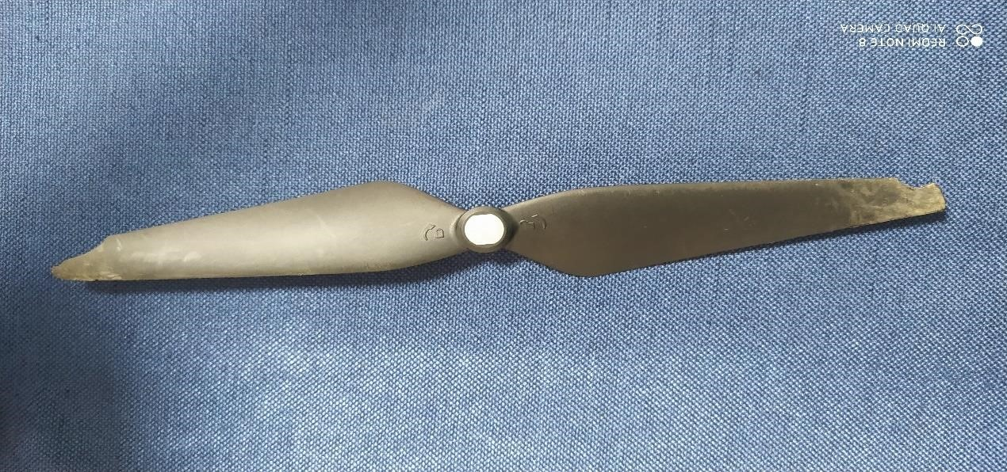

Figure 8.17 Broken propellor

**.**

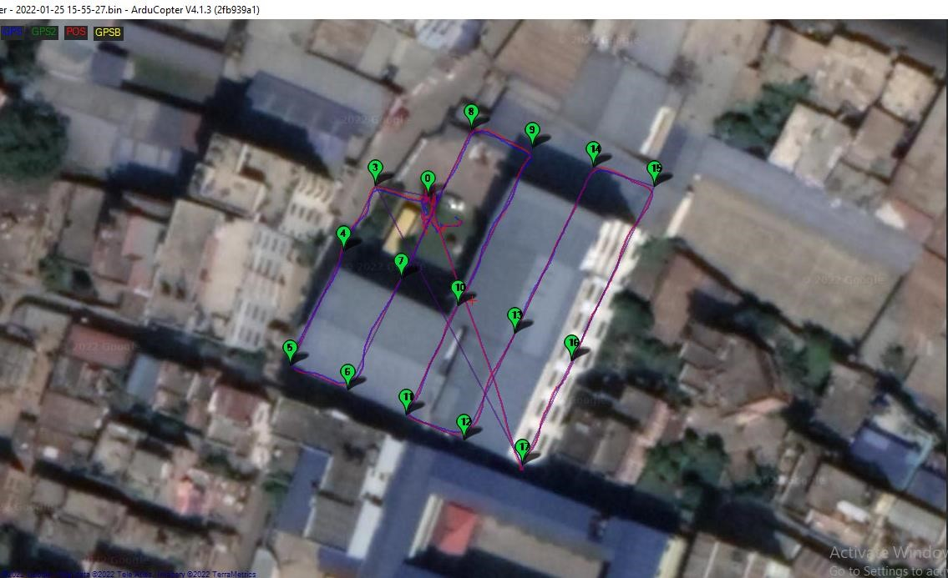

Crash Point

Figure 8.18 Flight path showing crash point

On the basis of observation, it was clear that there was some unexpected problem in the roll maneuver. Figure 8.19 shows the plot of roll movement over distance and the actual point in the flight path where an unexpected divergence occurs. We can clearly see some unexpected divergence in the roll movement at the time of lading.

**.**

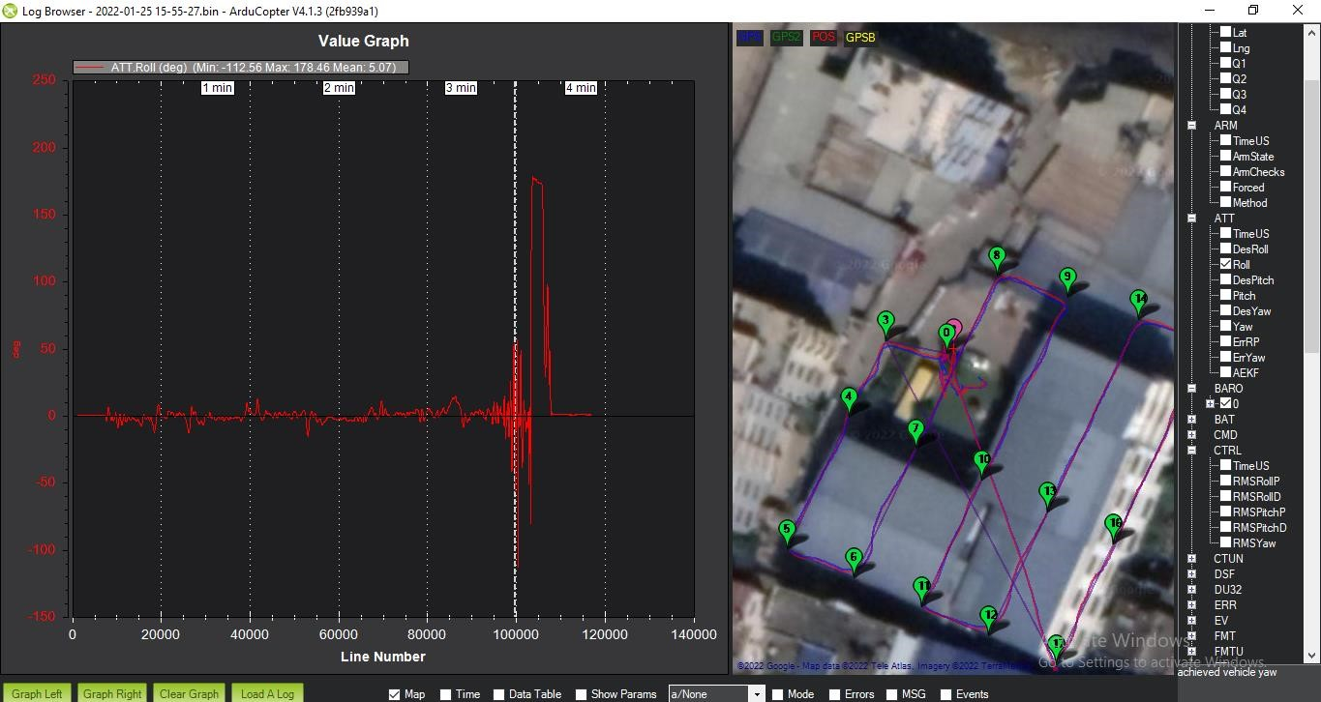

Crash point

Figure 8.19 Roll movement and the crash point

Figure 8.20 shows drone actual roll (red) over the desired roll (green) which is very much in accordance in the first left phase but suddenly gets a high divergence.

At a first glance it seems the PID don’t work properly to accomplish the error generated but while plotting the desired roll(blue), actual roll (orange) and rms roll p gain parameters (green)together (figure 8.21) it is clear that PID actually works well to compensate the error but somehow it couldn’t. It indicates towards the mechanical failure rather than the software failure. Going in a more details in the pixhawk guide manual where it is been suggested that sudden spikes in the roll, yaw parameters is most likely to occurs because of ESC sync failure [20]. ESC sync failure is a state where ESC and motor goes out of sync as ESC have to track the motor position for its proper control which goes thousands of times per second. This proven true by the manual test where sudden spikes or changes in the throttle causes the motors to goes out of sync resulting in a random motor to operate either slow or stop. Other possible reason might be the displacement of battery from its position causing instability. Thus, re-calibrating ESC and Fixing battery with zip tie eventually solve our problems.

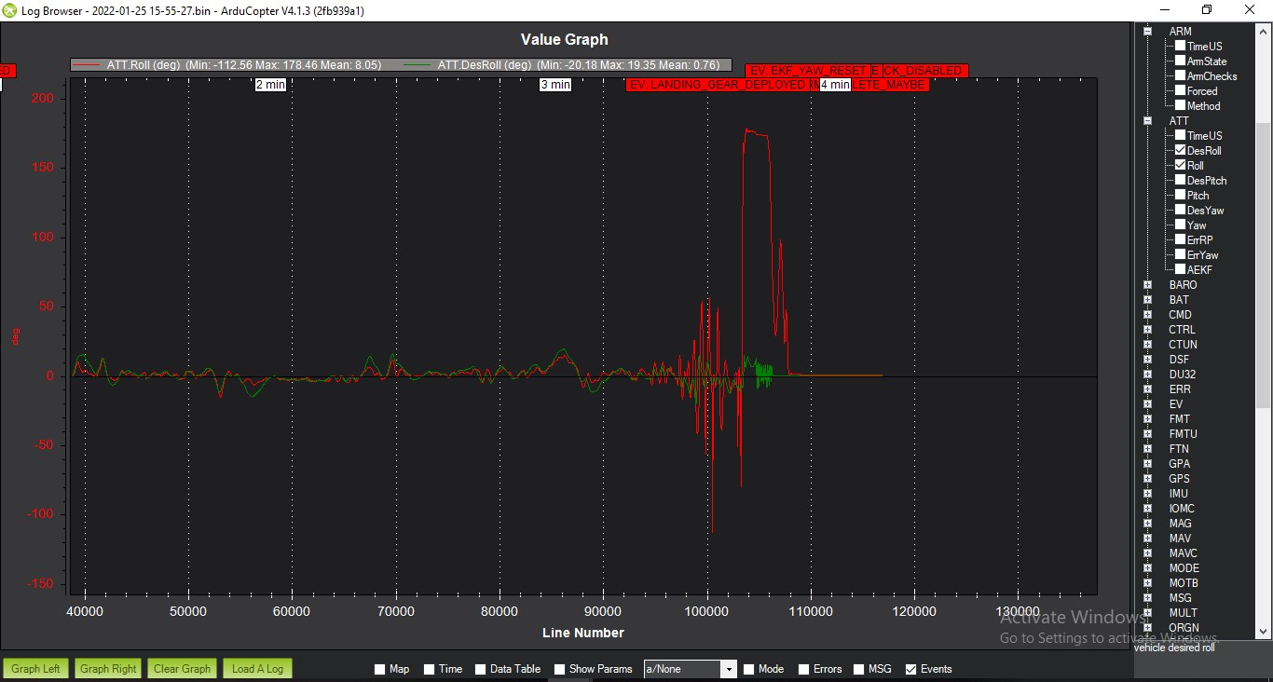

Figure 8.20 Actual roll over desired roll

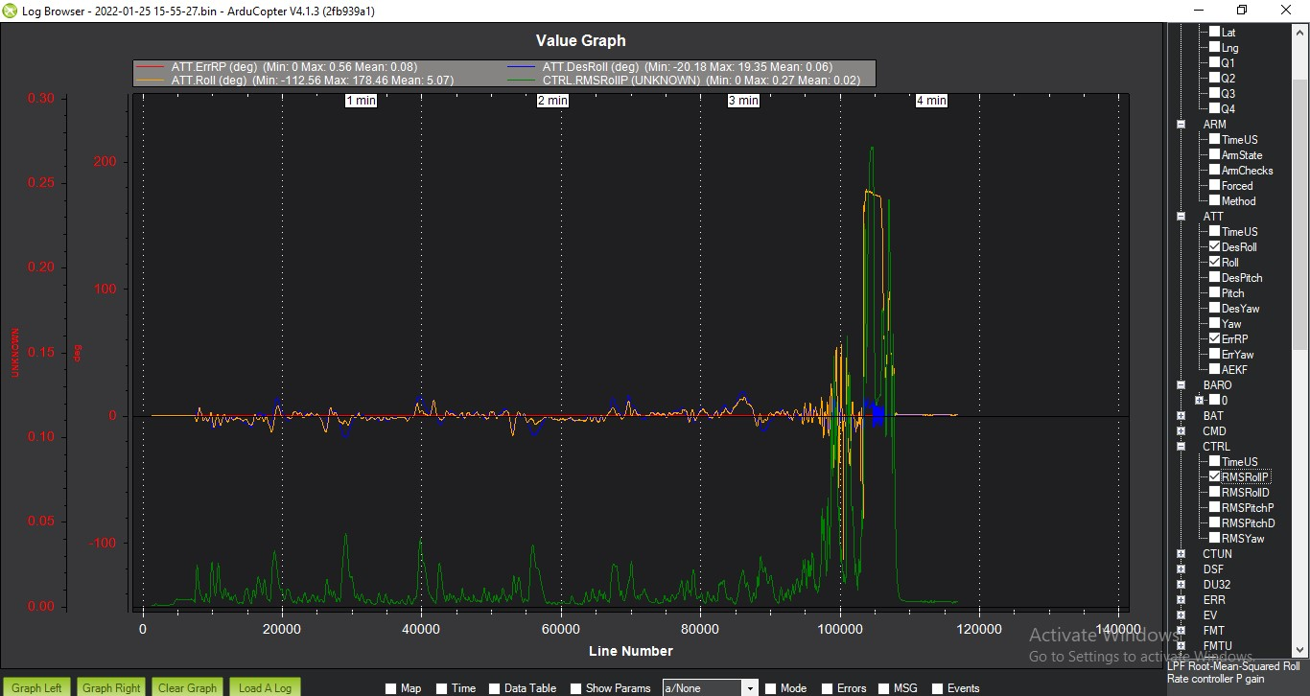

Figure 8.21. Desired roll(blue), actual roll(orange),rms roll p(green)

**Conclusion and Finding:**

Despite of the crash at near point, we were able to took the orthographic pictures of the college premises. After loading all the pictures to the Pix4D software we were able to generate 3D map of an area. Screenshot of generated 3d map is shown in the figure below

Poor texture

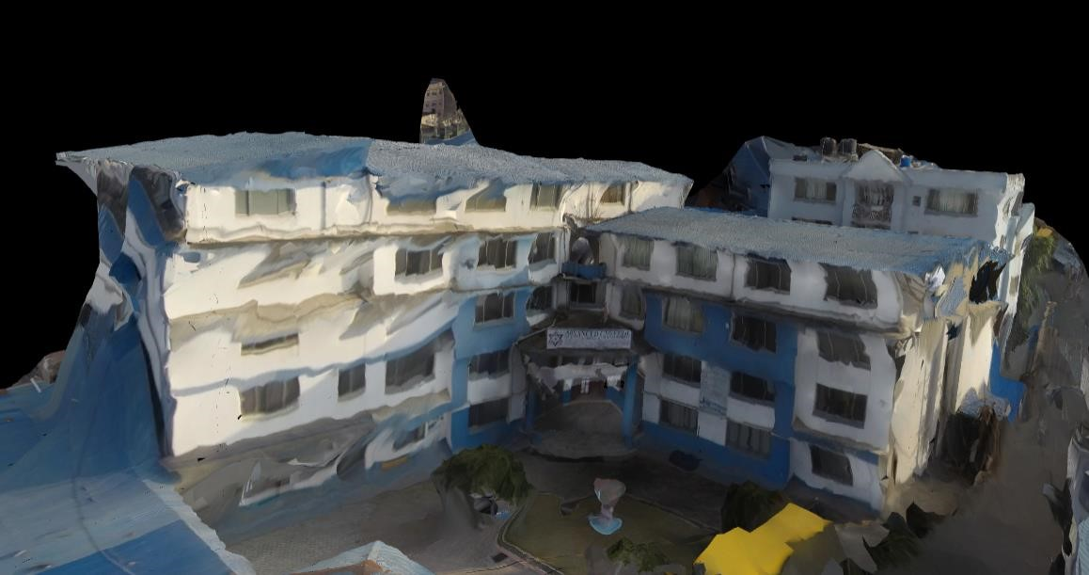

Figure 8.22 Front view of the generated 3d map of ACEM old building

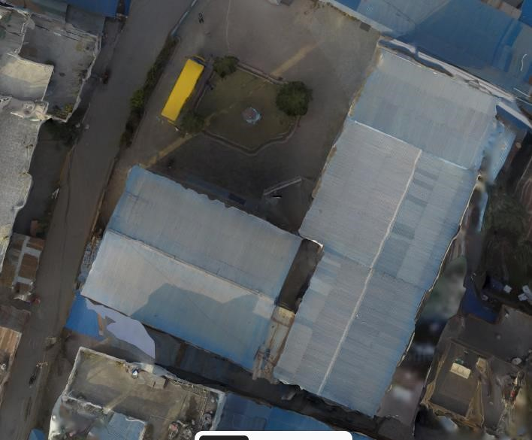

Figure 8.23 Top view of the generated 3D map of the ACEM old building

Poor texture

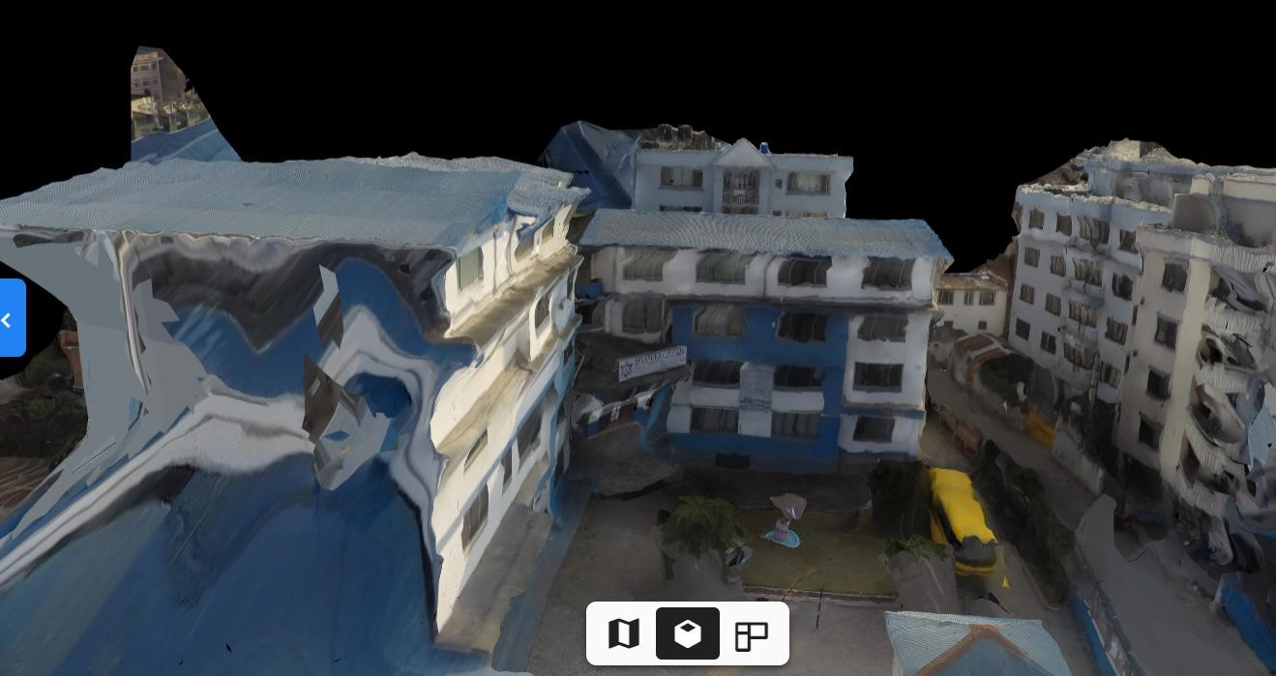

Figure 8.24 Left side view of the generated 3d map of the ae ACEM old building

From the figure above it is clear that top view (figure 8.23) has less noise than that of the front view and side view resulting in the high texture and detail at top view rather than front and side views. The reason behind it is the angle at which the pictures have been taken. Here no picture had been taken at an oblique angle rather every single photo is at orthomosac (at right angle) making the top view details more clear than side and front view.

# TIMELINE

|  |  |  |  |  |  |  |  |  |  |
| --- | --- | --- | --- | --- | --- | --- | --- | --- | --- |
| Task |  |  |  | Time | |  | | |  |
|  | July | Aug | Sep | Oct | N | ov | | Dec | Jan |
| Study Research |  |  |  |  |  |  | |  |  |
| Problem  Analysis |  |  |  |  |  |  | |  |  |
| Requirement  Analysis |  |  |  |  |  |  | |  |  |
| Learning Skills |  |  |  |  |  |  | |  |  |
| Assembling |  |  |  |  |  |  | |  |  |
| Manual Test |  |  |  |  |  |  |  |  |  |
| Automation Test |  |  |  |  |  |  | |  |  |
| 3D map of old  College Building |  |  |  |  |  |  | |  |  |
| 3D map of New  College Building |  |  |  |  |  |  | |  |  |
| Documentation |  |  |  |  |  |  | |  |  |

|  |
| --- |
|  |

Completed Task

Table 9.1 Work Timeline

# FINANCIAL FUNDING

The total cost of the project reaches to around Rs: 2 lakhs. Department of Computer and Electronics in Advance College of Engineering and Management issued the cost of Rs: 30,000 as a part of the major project while the rest of the cost is funded by Research and Innovative Unit (RIU) in Advance College of Engineering and Management. Combining both the funds RIU also help us to manage the logistic components and space required for the completion of the project. Figure 55 shows project investors interest vs their investment value. It shows that RIU has a high investment with high interest in the project whereas Department of Electronics and Computer Engineering, ACEM has low investment with high interest value.



Interest

Investment

Department of Computer

and Electronics, ACEM

Research and

Innovative Unit,

ACEM

Table 10.1 Project investor interest versus their investment

# LIMITATION AND FUTURE WORK

## LIMITATION

However, the system is able to accomplished its primary goal, the system is yet not stable enough for a practical use. Moreover, absence of Gimbal and camera triggering module makes difficult to take oblique images causes poor texture of the generated 3D image at its side view. In addition to these, operation flight time is still limited despite of the fact the its sufficient to general mapping purpose. Also, the system is not robust to handle extreme external environmental factors like temperature, humidity, wind speed and so on.

## FUTURE WORK PLAN

We aim to include the following objectives in the future:

* Improved the system stability
* Equipped the system with gimbal and camera triggered module for oblique images.
* Equipped the system with onboard computer and other functional sensors like lidar for more robustness.
* Make 3D mapping using Drone more reachable to accessible.

# REFERENCES

1. W. Budiharto, E. Irwansyah, J. Suroso, A. Chowanda, H. Ngarianto and A. A. S.

Gunawan, “Mapping and 3D modelling using quadrotor drone and GIS software,” *Journal of Big Data,* vol. 8(1), pp. 1-12, 2021.

1. M. R. Haque, M. Muhammad, D. Swarnaker and M. Arifuzzaman, “Autonomous quadcopter for product home delivery,” in *International Conference on Electrical Engineering and Information & Communication Technology*, Bangladesh, 2014.
2. S. Pytharouli, J. Souter and O. Tziavou, “Unmanned Aerial Vehicle (UAV) based mapping in engineering surveys: Technical considerations for optimum results,” the 4th Joint International Symposium on Deformation Monitoring, 2019, May.
3. K. Iizuka, M. Itoh, S. Shiodera, T. Matsubara, M. Dohar and K. Watanabe, “Advantages of unmanned aerial vehicle (UAV) photogrammetry for landscape analysis compared with satellite data: A case study of postmining sites in Indonesia,” Cogent Geoscience 4, 2018.
4. H. Chuangfeng, L. Pingan and J. Xueyan, “Measurement and analysis for lithium battery of high-rate discharge performance.,” Procedia Engineering, 2011.
5. A guide to understand Lipo Battery, Hyperion-World.com.
6. H. M. Qays, A. J. Bassim and D. S. Ayman, “Design and Implementation of Autonomous Quadcopter using SITL Simulator,” vol. 20(1), pp. 1-15, 2020.
7. G. S. Written, “electricrcaircraftguy,” 12 April 2014. [Online]. Available:

https://www.electricrcaircraftguy.com/2014/04/propeller-static-dynamic-thrustequation-background.html.

1. M. D. Scythian, “YouTube,” 15 April 2017. [Online]. Available: https://www.youtube.com/watch?v=BfDP1ytkUls.
2. “Pixhawk User Manual,” Radio Link, [Online]. Available: http://radiolink.com.cn/doce/UploadFile/ProductFile/PIXHAWKManual.pdf.
3. C. B. Karim, “THE DESIGN AND DEVELOPMENT OF A GENERAL-

PURPOSE DRONE,” School of Science and Engineering, Al Akhawayn

University, Ifrane, Morocco, 2020.

1. A. Erasmus, “youtub.com,” PX4 Autopilot-Open-Source Flight Control, 6 July 2020. [Online]. Available: https://youtu.be/nEo4WGl4Lgc.
2. “Wikipedia,” [Online]. Available: https://en.wikipedia.org/wiki/Integral_windup.
3. “Apmonitor.com,” [Online]. Available: https://apmonitor.com/pdc/index.php/Main/ProportionalIntegralDerivative#:~:tex t=Derivative%20kick%20occurs%20because%20the,an%20upper%20or%20low er%20bound.

1. “Vectornav.com,” [Online]. Available: https://www.vectornav.com/resources/inertial-navigation-primer/mathfundamentals/math-attituderep.
2. D. Brescianini, M. Hehn and R. D'Andrea, “Nonlinear quadcopter attitude control: Technical report,” ETH Zurich, 2013.
3. R. Battulwar, G. Winkelmaier, J. Valencia, M. Naghadehi, B. Peik, B. Abbasi, B.

Parvin and J. Sattarvand, “A practical methodology for generating high-resolution

3D models of open-pit slopes using UAVs: Flight path planning and optimization,” vol. 12(14), p. 2283, 2020.

1. “pix4 autopilot,” Auterion.com, 12/ 3/ 2020. [Online]. Available:

https://docs.px4.io/master/en/frames_multicopter/holybro_s500_v2_pixhawk4.ht ml.

1. “Ardupilot.org,” ArduPilot Dev Team, 2021. [Online]. Available: https://ardupilot.org/planner/docs/mission-planner-flight-data.html. “Ardupilot.org,” [Online]. Available: https://ardupilot.org/copter/docs/commondiagnosing-problems-using-logs.html